»KAREL HORAK GROEP 4 DESMO
Karel Horak
and his desmo space miracle

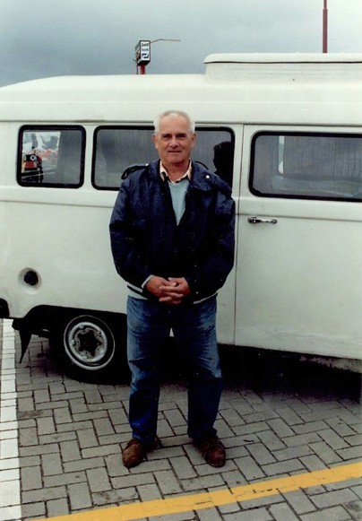
At the end of the year a long but powerful, final piece of the desmo series with models from inventors / designers that I have met myself. The stories behind the models from my Desmo collection.
01
DOOR HENK CLOOSTERMAN

It has been 28 years since I met Karel Horak at Assen and later told the following about it in "Desmonieuws 2" (Strada 1992):

We found out by a chance that Horak is still alive and that his system discussed in our book was also implemented. This fact triggered a lively correspondence that eventually led to a meeting at last year's club race. Francisco [ex-friend and co-author desmo book] * and I met an approximately 60-year-old man who had come to the Netherlands with his girlfriend and [her] son in an old van from Holice (CS). Karel took the cylinder head and he gave us a lecture.

* Between [ ] present time additions.
Karel, a retired Czech engineer, has been interested in desmodromics since the World War II and he is convinced of the benefits. "I believe that Desmo's time is still to come." He already knew several versions but came up with a wonderful new system that can rightfully be called a space wonder. He even got a patent on it [CZ105709]. But the Czech state-owned companies did not see the potential and would rather continue to build on their products. The state specialists believed that his invention was only of theoretical importance. That frustrated him so much that he sometimes wanted them to go to hell. All his free time of four years was spent on the implementation of a two-valve desmo cylinder head. He mounted this on a 250 ESO with which he rode smoothly (revved up to 11,550 rpm) to his work. He later sold this motorcycle and he believed it should still run. After this he bought a CZ 125 street racer and did
the above mentioned again. This bike ran at 14,000 rpm, but was never
used in races, because the two-stroke era had already broken through. When his frustrations were sufficiently reduced by this, he started to build sprint engines. Until the age of 60 he has participated in official sprint races!

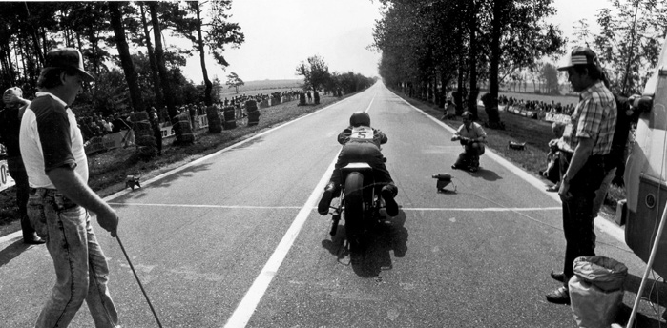
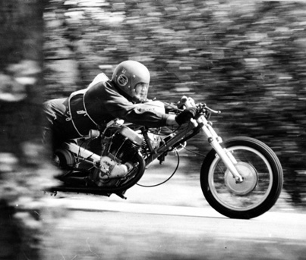
STRADA nr. 8 - 2019
03
16
02

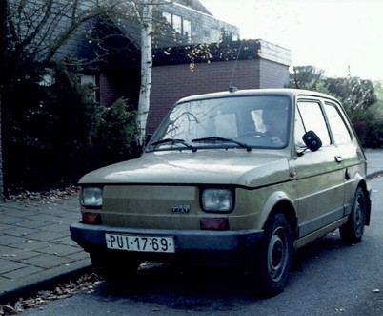
Model collection expanded with a four-valve radial head
04

I had already announced in "Desmonieuws 1" that the Desmo collection would be expanded. That does not happen automatically, but it was a success again: Karel was fortunate enough to make a copy of his system (from aluminum) for this purpose. He needed about three months, which I found quite lengthy in my naivety. Regular correspondence took place during that period. The result exceeded all expectations. Instead of a version of a single valve, Karel made a model of a working radial four- valve head. He was working on it for nine (!) weeks. Because his whole house was covered with things and he seemed to be unable to think of anything else, his girlfriend, with whom he has a LAT-relationship, had to stay away for a while.

Karel thought it was a bit too inadequate to entrust it to the Czech PTT and then decided to just deliver it personally. When I saw the model, I was excited and disappointed at the same time. The interior was very nice, although a bit roughly finished, but the entire enclosure resembled a "rabbit cage". At 100 meters you could see that it was a typical "Eastern block thing". Slowly a plan went through my head: "I'm going to dismantle all that nicely and put it in between Perspex plates." Not soon after Karel had left in his Polska (Fiat 126), the model was already falling apart. After many hours of specialist work (here again a thank you to Piet Hogervorst), the model became part of the rest of the family. I will continue to be silent and let the photos speak for themselves.

It's very sad that in the first sentence we say that Horak is still alive and that the editors had to add his death notice at the last moment. Karel came to bring the model on November 28 and two months later he died of a heart attack at the age of 66. Such a pity that this

04 Karel in his Polska just before leaving home. 05 A conical cam pair, opposite and mounted next to and towards each other, on the end of the axle.

06 If there only was a YouTube video about how these cams were made….

sympathetic, talented desmo-soulmate and motor man had to be lost. We had made so
many plans and could still share everything. Unfortunately, it could not be.

The Space wonder (group 4 desmo special)
As we have seen with the Packer system, the large up and down masses and friction appear to be the main disadvantages with this type of desmo. Karel Horak managed to overcome both disadvantages with his invention. For this he used conical cams, which is quite unique in desmodromics! There are two cam pairs on the same axle. Each pair is mounted opposite (with the straight backs) next to and towards each other. The conicity is therefore also opposite. With this arrangement, the framework can be made as thin and light as possible (see photos and the patent drawings and text below)

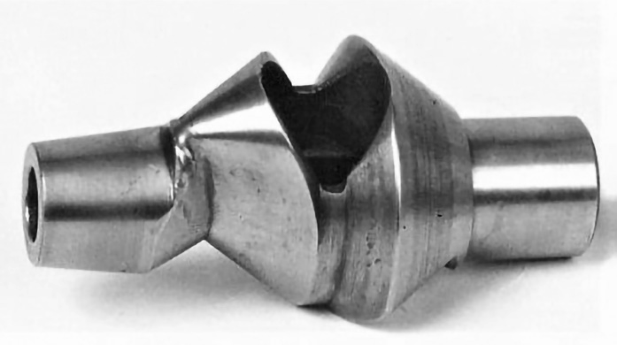
05

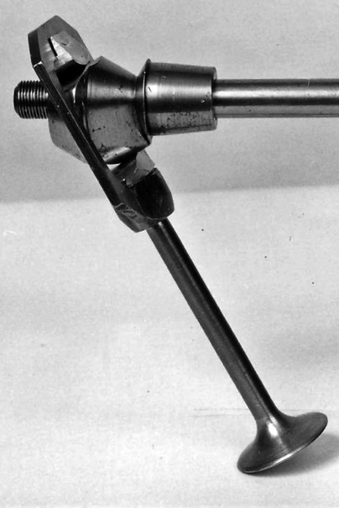
- Karel Horak at Assen, 1991.
06
17

- Karel Horak sprinting on his ESO (JAWA).

- Straw bales against tree trunks. A sham security against crashes, but in "the good old days"

all that was still possible.

STRADA nr. 8 - 2019

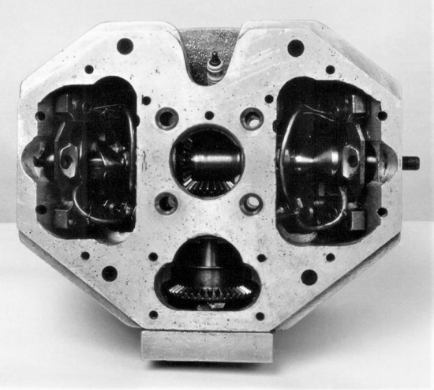
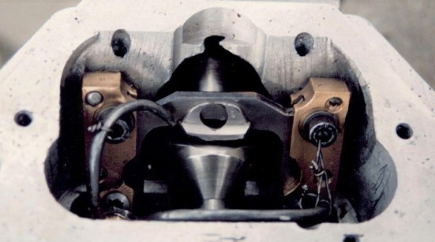
»KAREL HORAK GROEP 4 DESMO
08

07

I could not acquire the original desmo head. The Horak family and in particular the husband of Karels' daughter Eva and the mother of grandson Vojtech, valued this head as "both a unique construction, as well as a unique piece due to the artisan work". [Unique, both constructively - in terms of design and craftsmanship]. She wrote to me: "And now to your interest in the Desmo cylinder head: don't be angry, but we don't want to sell it." Unfortunate for me, but a very reasonable decision of course.

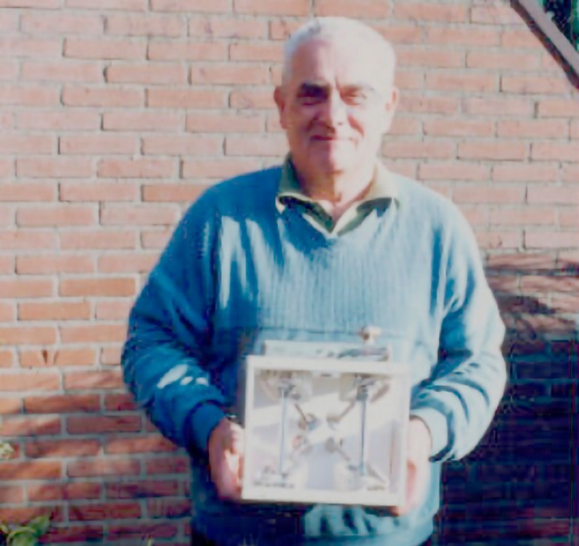
"The Horak skull lifted" is the caption to photo 5, as posted on the content page of the Strada 2 from 1991. Editor Lammert Steinfelder made the following intro to my Desmonieuws: "No kleptomaniac, but a kleptophile. Henk Cloosterman doesn't get tired of those valves.” ** Karel had this head with him at Assen. Photographed freehand on the pavement of the Parc Fermé. Clearly different from the other head, both in the drive (right-angled bevel gears), as well as in guidance of the cam follower body (groove instead of rod). This is the cylinder head for the 125 cc Walter (CZ) racer.
09

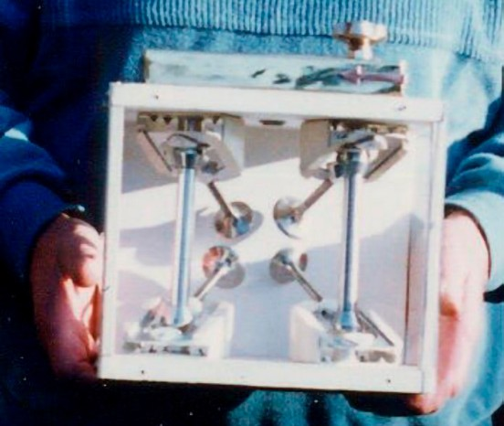
The model that Karel Horak brought to me was a wooden cabinet consisting of a base plate and two thick side plates. Four valve guide brackets were attached to this and both camshafts ran through. The insides were covered with a wallpaper. Two thinner side panels were screwed to it. Only at the top was a thin Perspex plate. Karel was a gifted engineer and a fine metalworker, but he was less skilled with wood. It is understandable that he wanted to beautify things with a brass cover. He also said that he was short of time because of the making the various components was very labour-intensive. He also had not made it easy for himself to make a radial valve (four valves per cylinder with the inlet and outlet valves diagonally opposite each other). Letting it run nicely in synchronization (simultaneous up and down) of these valves was not easy and not entirely successful. There was a lot of play between cams and cam followers. The outside had a brass cover plate. The long axis went through the round hole. Behind this plate were the two sprockets, the chain and chain tensioner (eccentric). There was also a red-copper arrow soldered on it to indicate the direction of rotation and a small signature plate.

18

** That still applies after all these years!
"Stopped talking Desmo" will be the reason for an In Memoriam in the Strada.
07-08 The cylinder head of the 125 cc Walter (CZ)racer.

09 Karel proudly shows his model in our back garden.

10 Zoomed in on the model.

10

STRADA nr. 8 - 2019

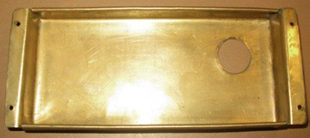

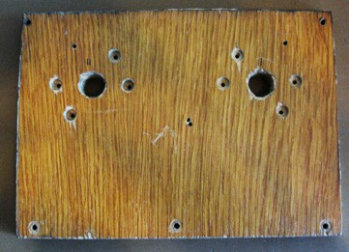
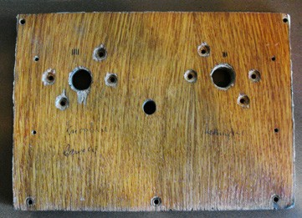
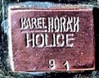
13
11
12

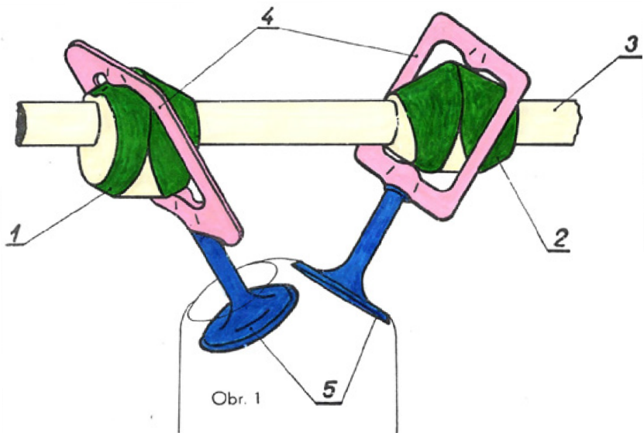
The amount agreed and advanced in Assen was NLG 300 and that was about the pension he was receiving monthly. On top of that, I have reimbursed the travel costs of NLG 225 and of course "some" extra such as a few free desmo books for his friends. All in all, quite a "bargain".
14

Karel's grandson Vojtech contacted me in 2015. He turned out to study at the HAN (Arnhem-Nijmegen High School) for a while. He visited me here and saw the correspondence with his grandfather and mother. He also translated the patent into English. For this article he has supplied some unique photos and facts. Below are the two claims from the patent in the English translation to explain the operation:

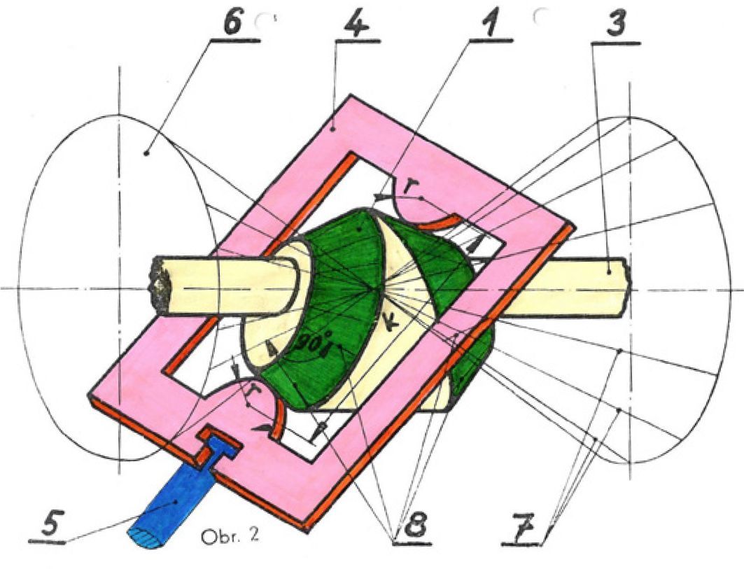
- Desmodromic valve train with inclined valves (5), sliding frame shaped guidance (4), detachable connection between the valve’s stem and cams (1,2) on the shaft (3), wherein each of the cams (1,2) has two functional surfaces made by two sets of lines (8) perpendicular [loodrecht staand op] to the surface lines (7) of the imaginary symmetric double cone (6) which is coaxial with the axis of the camshaft (3) with its connection point lying at the frame’s plane (4). The guidance is parallel to the one of the surface lines
of the double cone (6), having the same slope as the valve’s axis. The distance (K) measured between the centre of the rocker arm’s curvature with radius r, formed opposite to each other on the inside circumference of the frame guidance, measured on each surface line (7) of the double cone (6) is always constant.
- The desmodromic valve train according to the point no. 1 charac- terized by adjusting the valve clearance using axial shifting of the cams.

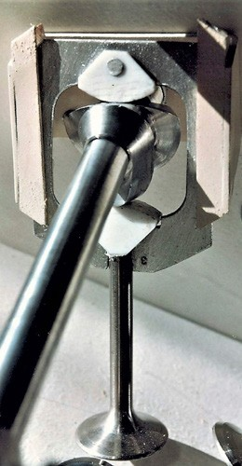
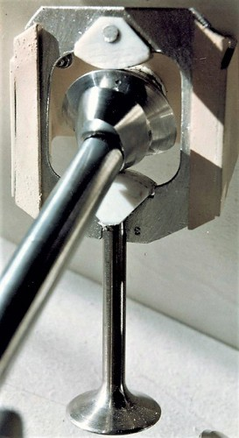
15
16
17

11-12 The wooden side plates from the original model.
13 Brass cover plate and small signature plate.
14-16 The patent drawings
16-17 Valve open (left) and valve closed (right). The Akulon guide and aluminum housing is painted. The akulon cam followers have been left untreated.
STRADA nr. 8 - 2019 19

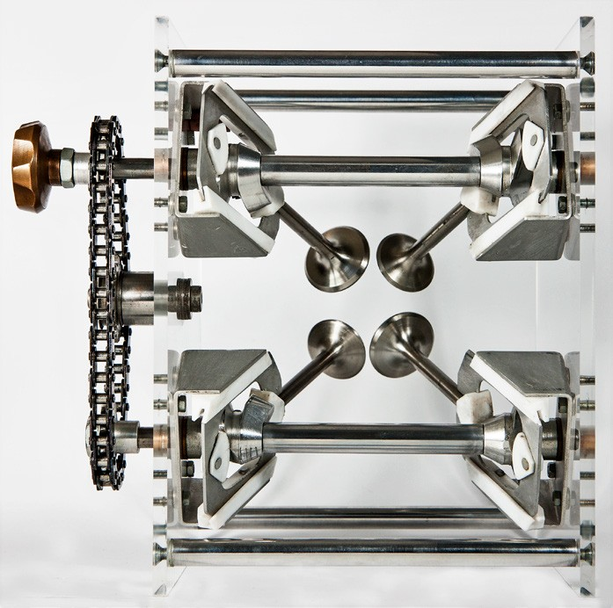
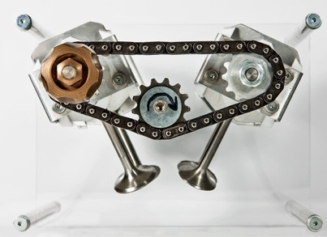
»KAREL HORAK GROEP 4 DESMO
19

18

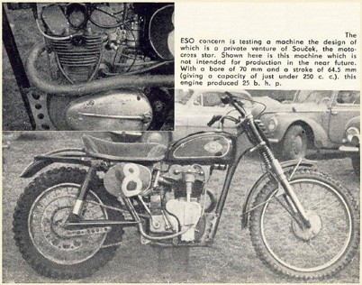
The first head recovered
20

As mentioned, Karel Horak had the first head with its first type of sliding system mounted on its ESO 250. This head, unlike the straight bevel gears in the head photographed at Assen, has a shaft with a worm gear transmission, as also applied to the first OHC JAWA Model 15 (1951).

In 1995, an article by Massimo Clark said:
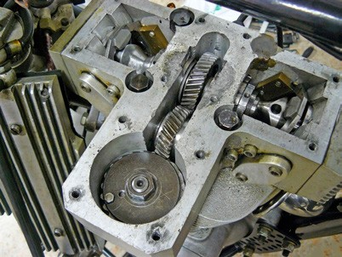
(IL ‘DESMO’ NON È SOLTANTO DUCATI, WWW.MOTO.IT/NEWS)
21

The mid-European motorcycle school has always been of a high standard and you could imagine that if the Czech technicians and those in what was then East Germany would have had the resources (or money) like in Western Europe, the history of racing bikes would have looked very different. ESO was an important brand in the speedway and at that time the engines produced by this small company from Divisov, were also known outside the Czech Republic in the speedway world. In the early 1960s, this company, taken over by Jawa in 1964, built a motor with a desmodromic valve control of the sliding guide type, which, when used in a motocross motor, was also used in races. The system used was somewhat like that of the Mondial from 1955 -56 which functioned properly.

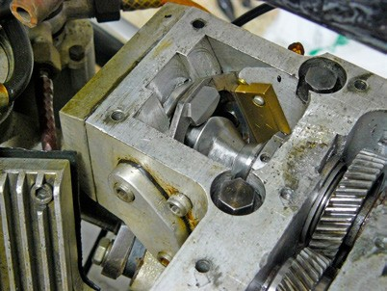
Here too there were two camshafts, each of the two camshafts in the head moved a valve in both directions thanks to two complementary eccentrics. These were in constant contact with a bow-shaped stirrup; this allowed the opening cam to push it down to lift the valve off the seat and with the closing cam to "pull" the slider upwards during the recall phase (together with the associated valve stem). The system worked but had two major fundamental limitations for a fast engine: the masses in alternating motion were considerable and the friction of the bracket (or rather, sled) was a non-negligible disadvantage.
20
22

This [Mondial] invention was patented and assigned to the Czech technician Jaroslav Cervinka. In the second half of the nineties I was able to photograph the head of this engine [Massimo Clarke] at the Reggio Emilia market, where it was for sale. [Note that this is a different head and system than Karel Horak's head on fig. 21 and 22. See the box with the separate desmodromic system of these Mondial engines].

STRADA nr. 8 - 2019

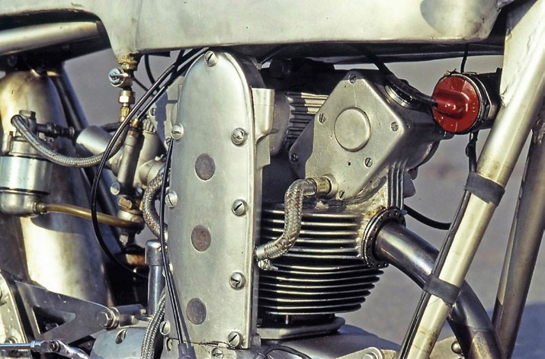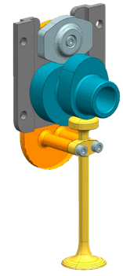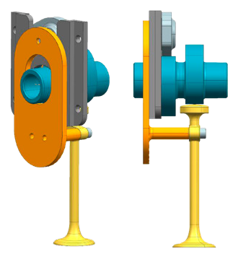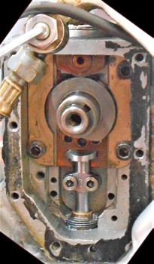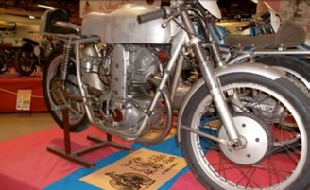
26
25
23-24 De 175 cc Mondial met desmokop.

- 3D-tekeningen van het desmodromisch systeem van de Mondial 175 cc (tekeningen: Andrea Ridolfi).

- De desmo-aandrijving wordt zichtbaar als het kapje wordt verwijderd.
24
23

Het desmodromische systeem (groep 4) van de Mondial 175

]. Recently I was even more lucky, which certainly deserves more explanation. I visited Gian Pio Ottone's extraordinary, authentic motocross collection, which contains more than two hundred beautiful off-road motorcycles, some of which have won world titles.
21

There are also three ESOs. I had already photographed two with push rod motors and rockers, but there was a third with a strange head shape. Indeed, it was equipped with a real aluminum structure (or a "castle", as the technicians sometimes say) that was mounted directly above the actual head, the upper part of which was nicely milled. A closer look was needed, so the cover was removed to be able to observe the internal organs. The surprise was extraordinary. This engine has a desmodromic distribution, realized with an absolutely unique system. In this case, too, it is a slide system, but the camshaft (divided into two parts connected to each other at the height of the central gear) is arranged longitudinally and not transversely. In other words, it does not have the axis of rotation parallel, but perpendicular to that of the crankshaft! This system, which was patented by Czech technician Karel Horak in 1962 (but the motorcycle that uses it, was built some time later), offers a stirrup for each valve that slides along two guides and moves in both directions. To operate it, ensure opening and closing conical cams with a complex geometry. The mechanical refinement and complexity of this version are evident. The camshaft is driven by a vertical shaft that is placed laterally on the cylinder by means of a worm-screw transmission and cylindrical gears.

Massimo Clarke has thus found (recovered) the head that Karel Horak had first made and sold. «

STRADA nr. 8 - 2019

18-19 Photos of the current model as included in my desmo catalogue. There is an extra-long shaft on which the copper knob and drive gear are mounted. A chain runs over an eccentric to the other gear to drive the other pair.

20 The desmodromically converted ESO
21-22 The first head on the ESO

Special thanks to VOJTECH BRYCHTA for translating the patent and for the granted pictures.

