Swing it out Henk!
About an Old School Desmo from JAP without cams, but with a swing mechanism. Report of Henk’s very last? desmo model.
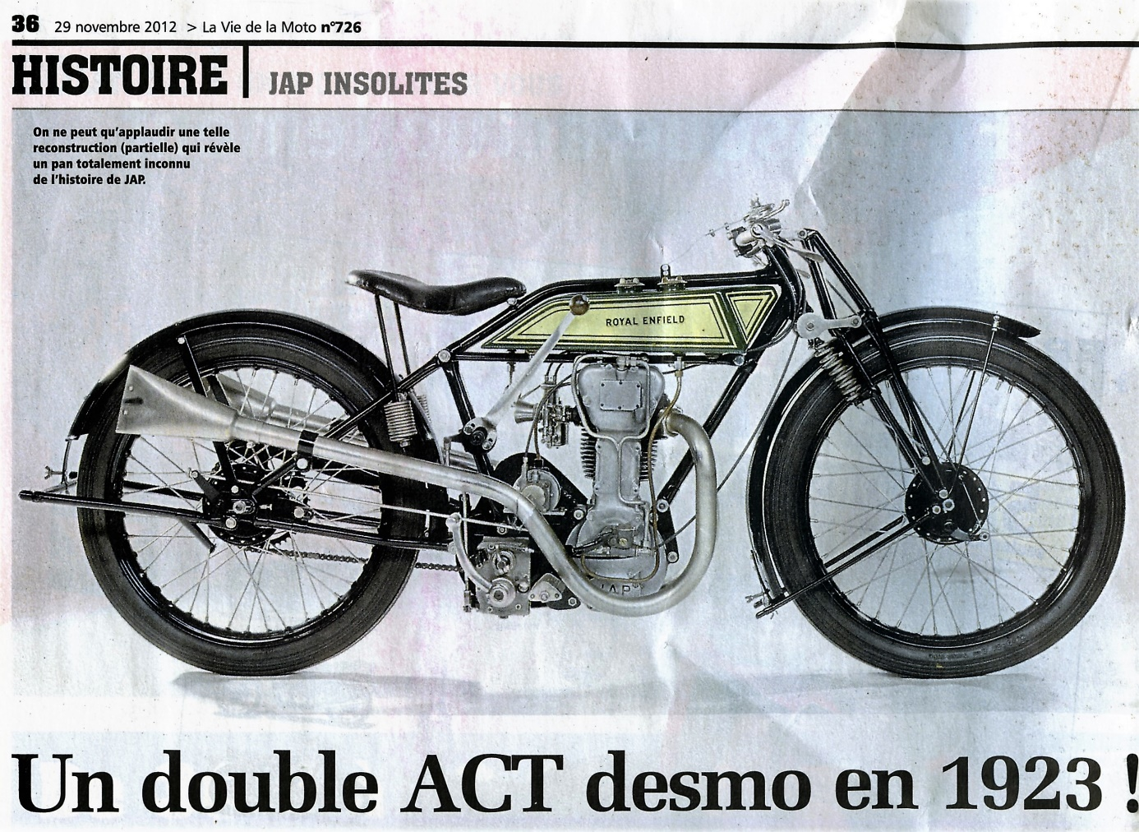
[The totally completely rebuilt experimental JAP desmo in a Royal Enfield bicycle part.] [Double ACT (Arbre à Cames en Tête) = DOHC.]
We will see later that this Double ACT (Arbre a Cames en Tête) (DOHC) typing is nonsense because there are no cams on the shafts at all.
[It is about a group 10 system (Classification): Systems in which the valve movement is initiated by means of a rod system by an eccentric or a crank-connecting rod mechanism.]

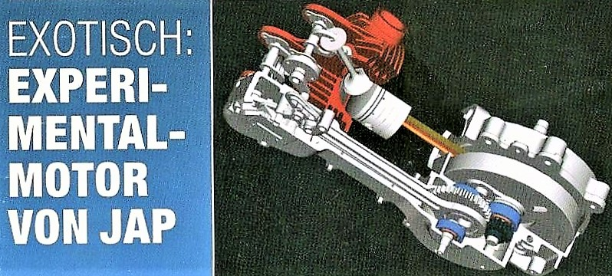
[3D view of the complete JAP block.]
It is (almost) finished: 'Henk swings it out'
The JAP system works with a swinging (back and forth) rocker arm shaft.
This story also started almost nineteen years ago. To be precise on Saturday October 12, 2002. The day I bought no. 6 of Motorrad Classic here just across the border in Kleve because I couldn't wait until it was for sale in Nijmegen. [Or even earlier: the day I saw the pre-announcement of that article in issue 5.]
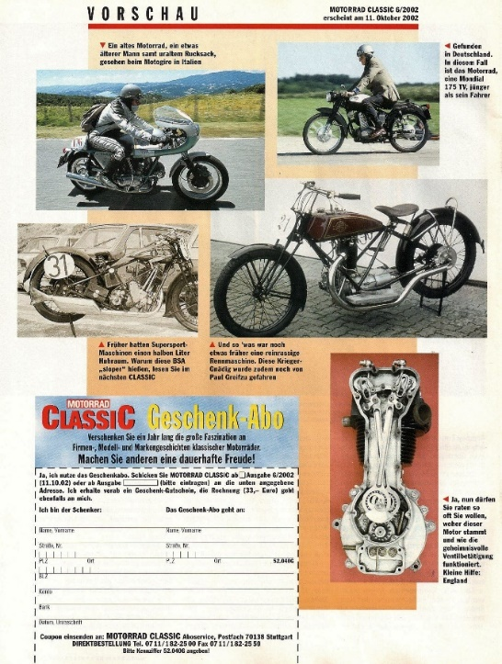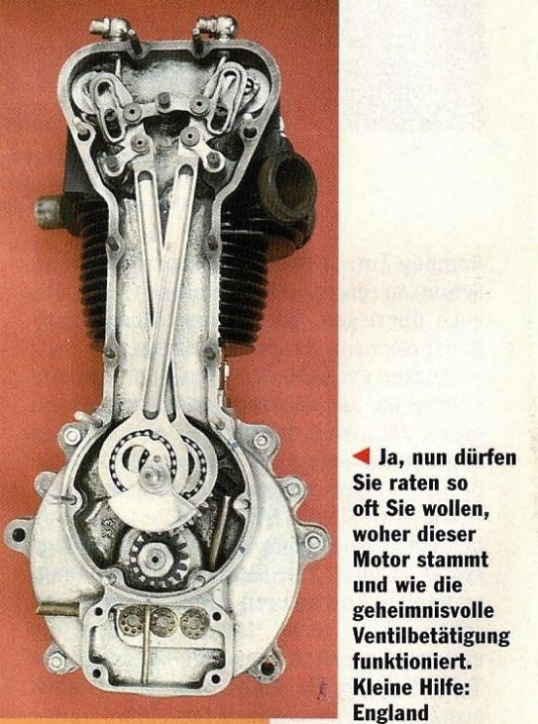
[The pre-announcement of the JAP-article in question.]
Later in this story I approached Martin Slancar (M.S.) and received the report he compiled on this engine [1]. 25 pages of illustrated description of the system. It contains the kinematic and mathematical descriptions and all variables, dimensions, and equations of motion. He had even worked out the construction of the missing rocker arm drive. This is not for hobby reasons, but on behalf of a certain Mr Brucha, the wealthy owner of this motorcycle at that time. M.S. has manufactured all missing parts himself in his workshop and assembled the engine. Werner Thum, a gifted, handy mechanic built this engine into a Royal Enfield frame and tuned it. Later I came across a French article [4] describing this whole story with pictures of the entire motorcycle. This subsequently came into the possession of Dieter Mutschler, a German JAP specialist and collector.
My very last desmo model story this time really depends totally on coincidences: This Desmo-JAP prototype, which must have been developed sometime in the mid-twenties, (partly?) executed and then kept under a workbench for almost half a century rusting away, is about to be thrown away when the (bankrupt) JAP factory buildings are demolished sometime in the early 1970s.
Coincidentally (1) there is someone who still values it and decides to save it from the scrap container. Several times it is sold at motorcycle parts jumbles until it ends up with someone from the Technology Museum in Vienna who also does not understand how this (incomplete!) system could have worked.
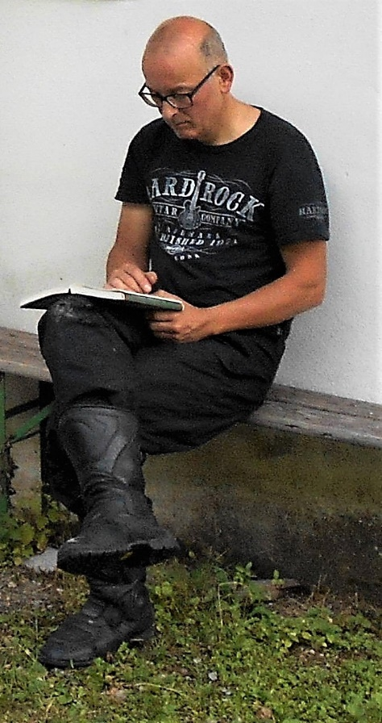
Purely by chance (2) Brucha bumps into Austrian Diplom Engineer Martin Slancar: www.classic-tech.at .
For Slancar it is a challenge to solve these kinds of puzzles for advanced users. In addition to his regular work in his workshop for mainly English classic engines, he invests about two years (1998/1999) in studying, measuring, describing and practical elaboration of the desmodromic valve control system of this 1-cylinder JAP engine. He was already making 3D drawings of it at the time. In the November/December 2002 issue of Motorrad Classic, a wonderful article by his hand is published, illustrated with those 3D drawings and photos of the existing engine, supplemented with the desmo valve actuation he devised and made himself. (Note: The crankcase with cylinder, the (empty) cylinder head and the eccentric with associated rod system were present, but the rest was missing).
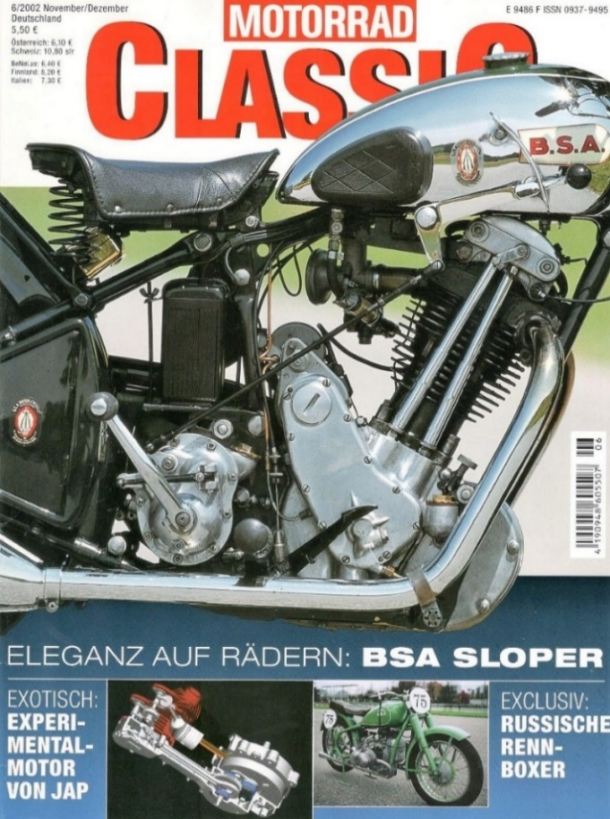
Fortuitous (3) I see a pre-announcement of that issue in the Nijmegen magazine shop [A to Z], I only visit a few times a year. This one was in issue 5, 2002. I bought that issue because in the section “Hausaufgaben” there was an excellent article about restoring the 350 Ducati mono with 4p. text and 38 photos. No. 6 wasn't a bad buy either. Besides of course that fantastic article about the JAP-desmo, also a report of the Moto Giro d ‘Italia from June 16-20, 2002. With beautiful photos of many Bevel-twin Ducati's.

[Cover of Motorrad Classic with the article about the exotic, experimental JAP - motorcycle.]
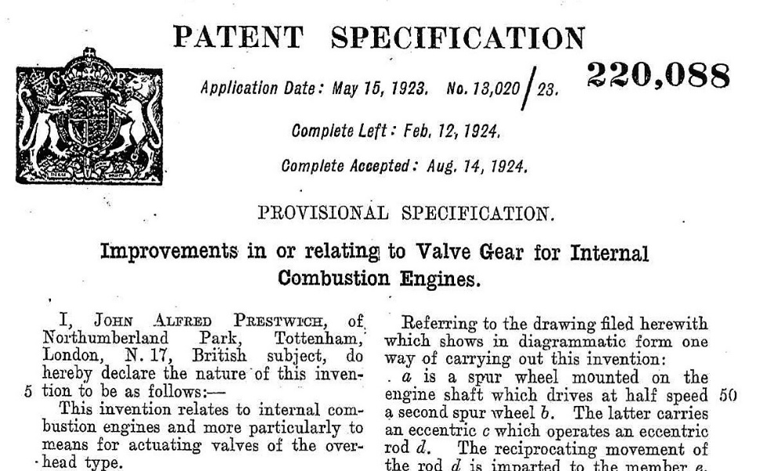
[John Alfred Prestwich's desmo patent, filed in 1923.]

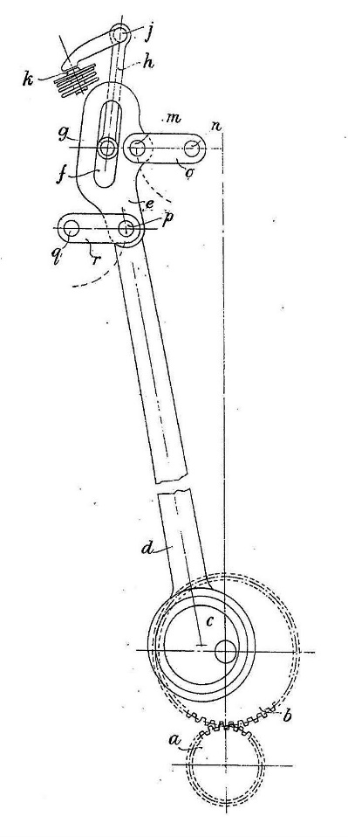
Then it turned out (4) that I also happened to own a copy of the desmo patent for this system; requested by Mr. J.A. Prestwich (JAP) himself. Brucha, Slancar and the M.C. editors were not aware of the existence of a patent. In the January/February issue of 2003 appeared in the section 'WWW. mal kurz reingeschaut' a mention of this find and a rather favourable description of my website 'Desmodromology'. When I contacted Slancar sometime later, I was no stranger to him, because he had already learned about 'desmodromology' before and he had read that part about that patent.
I asked him if he would like to make a model of this bike for me. He was willing to do that, but it would become a kind of hobby project, which he would only be able to work on outside normal working hours.

[Patent drawing of the present system.]
Even though I could not make time demands and he used special pricing for labour, materials and machine use, the quote still came to an amount for which you could buy a brand-new Ducati Monster 600 (f 18,000, =). That of course could not have been the idea, and he understood my objection and that I had to drop this assignment.
Coincidentally (5) this motorcyclist (a.o. a 4-valve Rudge from 1930) was still among us and in 2021 still had those 3 D files somewhere on his computer. A big opportunity that after renewed contact he was willing to let me use these drawings for a (substantial) payment.

[The Austrian Martin Slancar, graduate engineer, about Y2K]
Coincidentally (6) I was able to get my cousin Vincent a little more enthusiastic and willing to put professional time and energy into my 'very last' desmo project one more time.
At the time, the drawings turned out to be made in a format that is no longer common and intended to be used for conventional CNC operations.
Rapid Pro (3D printing) did not exist then, and these files require a little more attention. Quite a bit of 'tinkering' had to be done before the print company (I-Materialise) accepted it as executable.
Coincidentally (7) I am still alive and kicking, and still have the drive, money, and energy to take on this rather stressful adventure.
Coincidentally (8), despite my age (70+) and life history, it turned out that I still had just enough brainpower and skills to be able to bring the project to a successful conclusion. Although severe osteoarthritis sometimes mercilessly slowed me down and I still ran into a few incomprehensible mistakes.
Coincidentally (9), my old (25 yrs.), trusty Chinese lathe and other tools that were now completely worn out did not let me down. Although I had to buy a new Dremel and various other stuff, such as Widia (Wie Diamant) = (Like Diamond) chisels, because printed steel (420 = 60% stainless steel infiltrated with 40% bronze) is not only very hard, but also tough and therefore difficult to machine. I planed (scraped) more than that I did cut the holes.
Last not least, Ducati quite coincidentally (10) did not go bankrupt in 1985 and we have a very much alive club and club magazine in which I was allowed to publish this story again; but that last one can't be a coincidence, can it? 😊

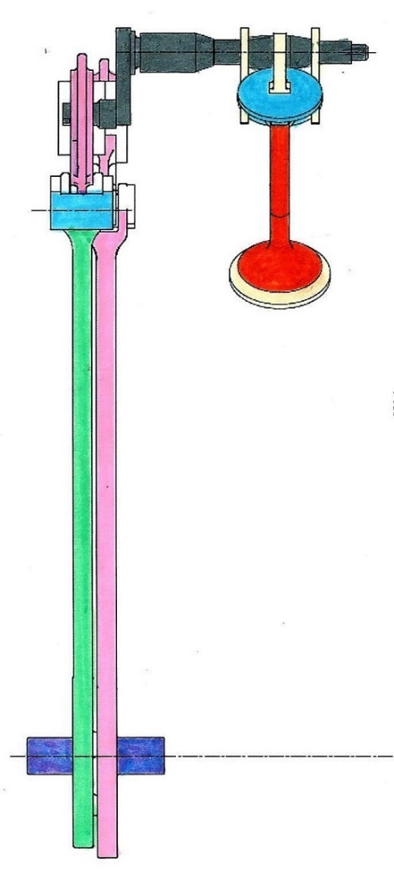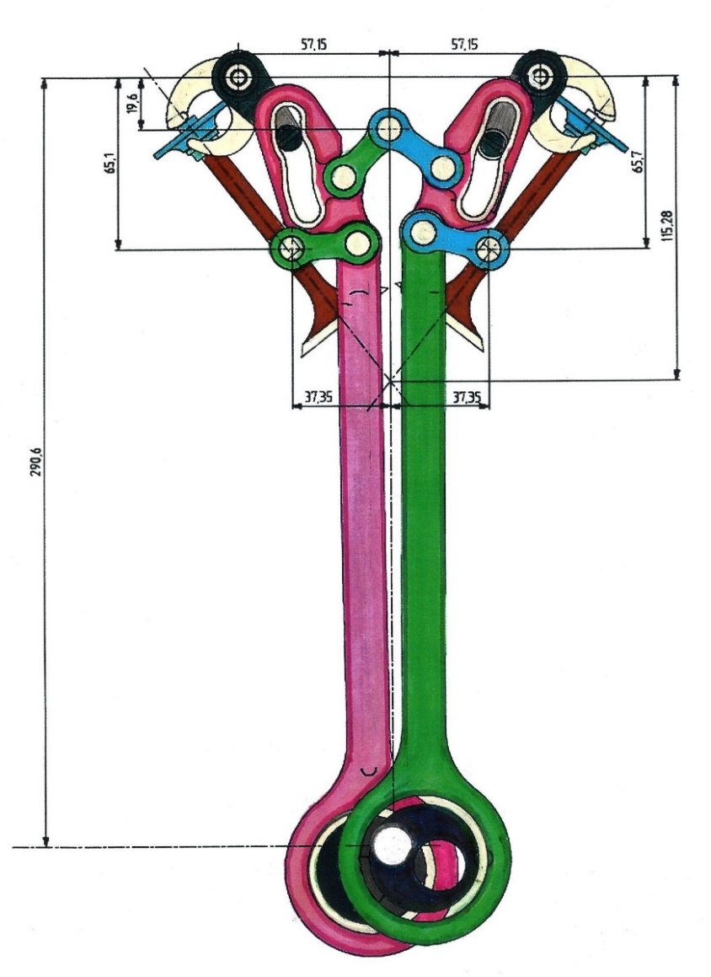
[Double line drawing with dimensions neatly coloured within the lines.]
Operation: The eccentric (black circles, with white shaft) makes the two push-pull rods move up and down. The green one is from the outlet and the purple pink one is from the inlet. Between the eccentric and the big end of the rods is a so-called 'max. capacity bearing' (Nineteen 7 mm bicycle bearing balls). Attached to the eccentric is a gear that is driven by a crankshaft gear (not shown).
The rods are connected to anchor points by means of links [green (left) and blue (right)]. A so-called Kulisse is rotatably attached to the end of each rod. That is the part with the specially formed groove between which the pin (black) that is attached to a kind of pendulum (also black) moves. Kulissen are again connected to a central anchor point by means of links.
By moving the groove up and down, the pin makes a reciprocating (pendulum) movement. The pendulum is connected to a shaft to which an opening arm and two closing arms (fork) are attached. This fork, in combination with the opening arm on the valve, encloses the valve spring seat that operates the valve forcibly (i.e., desmodromic).
Nb in the model I have omitted the crankshaft gear (15 teeth) and the eccentric gear (30 teeth). It makes a difference in construction height, construction depth, labour, assembly perils and especially in the wallet.
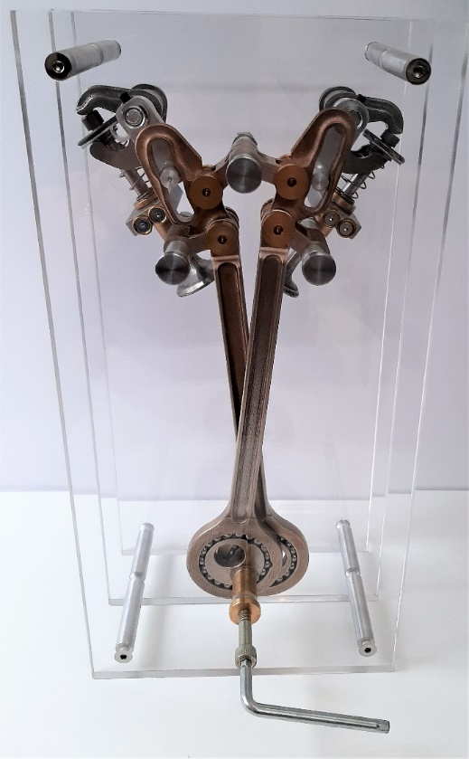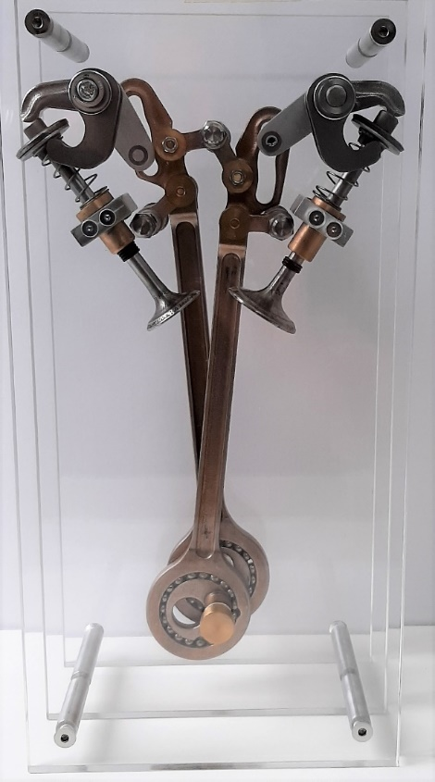
[Front view with simple drive.] [Rear view with a better glance on the complicated valve control.]

The making processes
The owners of my desmo catalogue know that I started seriously working on a model for this system before. About 10 years ago I put a lot of time into it, but it turned out to be impossible without Slancar’ s 3D drawings. Making your own eccentric, connected to rods by means of 'full capacity bearings' and the exact copying of the Kulisse slots, etc., turned out to be too much of a task.

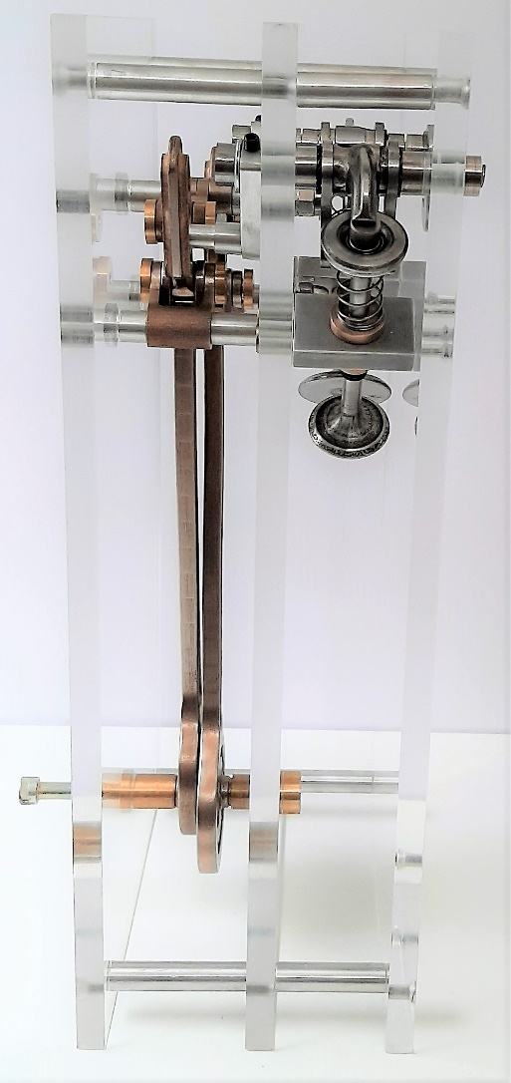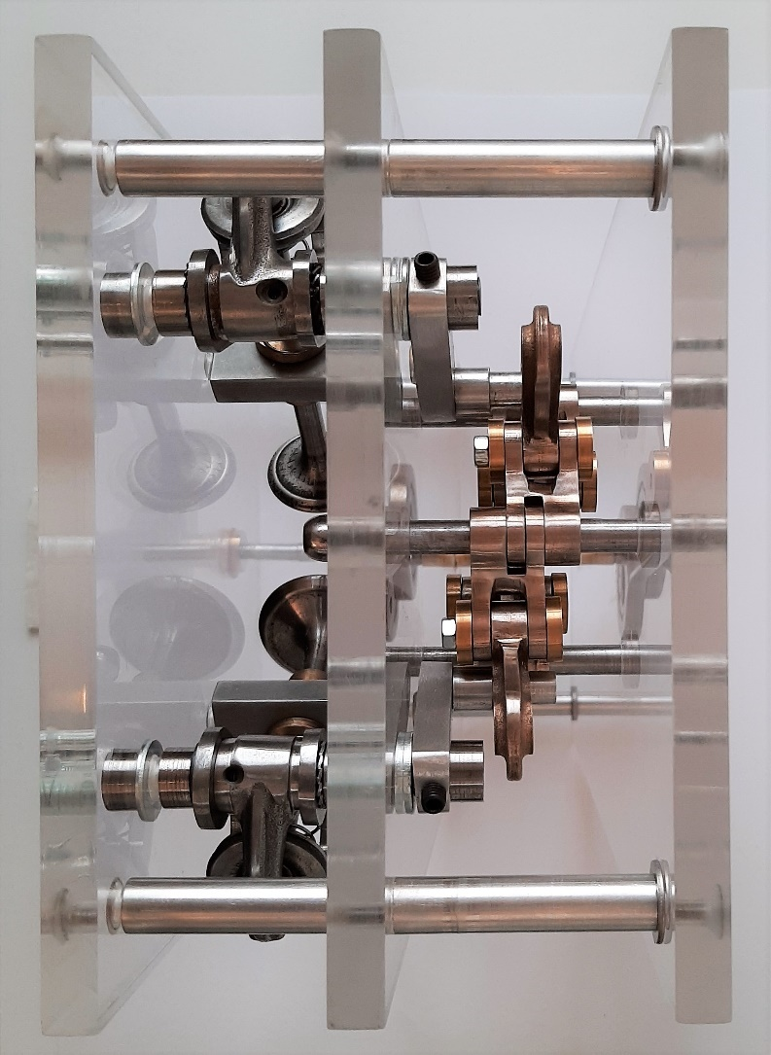
[Side view and top view.]
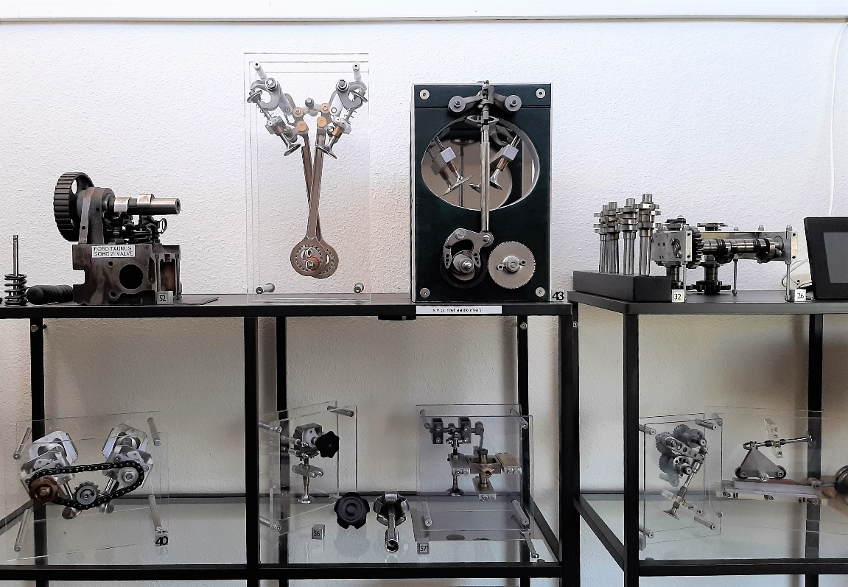
[Static JAP model sibling next to the Velocette model.]
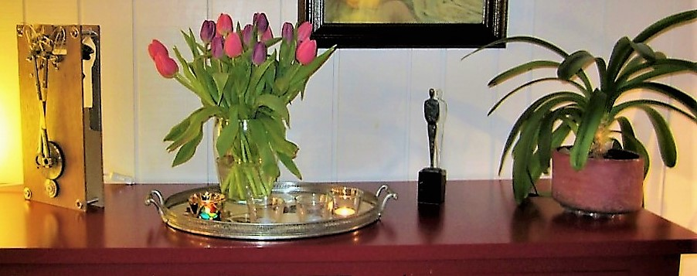
[Christmas 2012, the model was 'ready' as a concept version and the decision had been made to discontinue it.]
In the Corona lockdown summer of 2020, I contacted Martin Slancar again. I asked him if he could supply me with the parts with which I could build the model myself. It turned out to be a difficult contact because despite being 'too busy' he preferred to make it himself. I have not approached him for half a year and contacted him again in March of this year. Probably because of some guilt, he now proposed to use his drawings and leaving the execution of the model to me. As we'll see next, he certainly doesn't have to regret it.
I could fill an entire article with the story of the making process alone. To keep it short here: Preparing the printed parts for assembly was time consuming. As an example, here are two photos of the eccentric. The bearing races in the rods were just as rough, but much harder to grind and polish.
Drilling a hole right through the eccentric shaft was difficult. Only after I had sharpened a drill 'negative' (I learned that from Piet Hogervorst), it worked more like a planer tool. Only then it did work. Threads also had to be tapped for the drive (button or Allen key). That was also 'a thingy', which I took pictures of. But unfortunately, Strada space is limited.
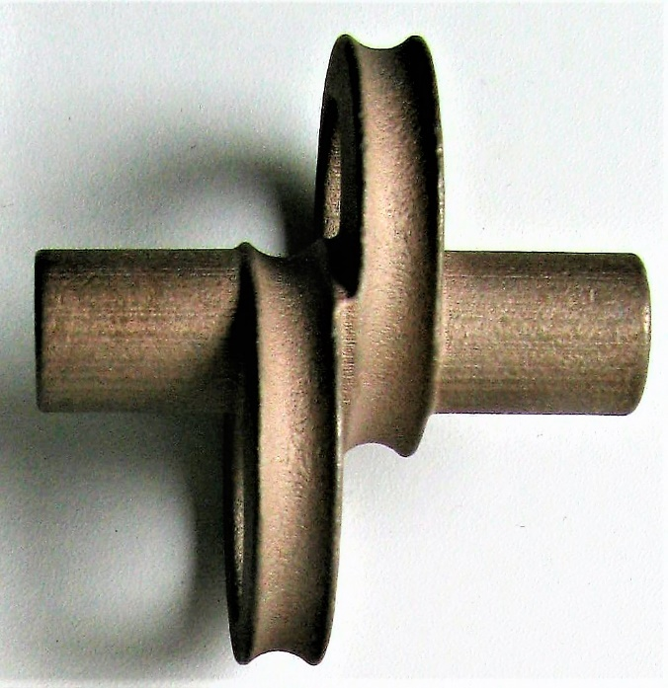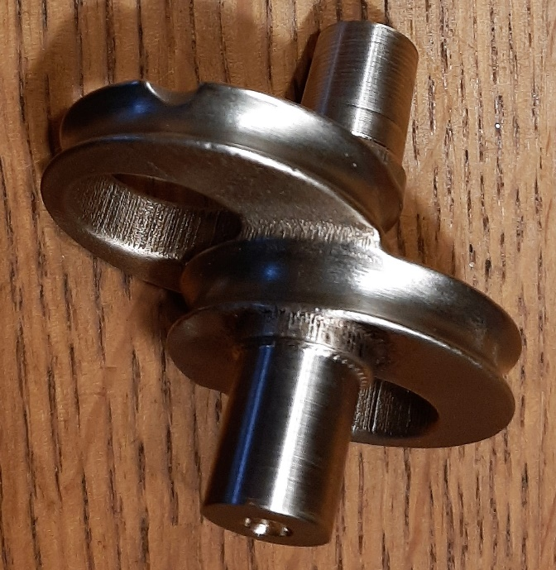
[The printed eccentric was a pain to machine.]
Kinematics (movement sequence)
A complicated matter, especially in this system of rods, links, and anchors. One hundred years ago and long before that, much use was made of so-called kinetic chains (linkages). Apparently Mr. JAP was also educated in this. There are still several chapters about this phenomenon in Robert L. Norton's Design of Machinery! It is indeed developed 100 years ago, but this time not by a desmo amateur, but most likely by Mr. John Alfred Prestwich himself (1874-1952).
“You have to be a devilish Englishman to come up with something like that” [Il fallait être britannique en diable pour y penser!] I read in the French article [4] about this engine.

So, the 'Gleitzapfen' (pen) goes up and down in the Kulisse groove. During most of the trajectory nothing happens (there is no pivoting movement) and only at the end it does. This last curve then gives a realistic acceleration and deceleration of the valve (timing).
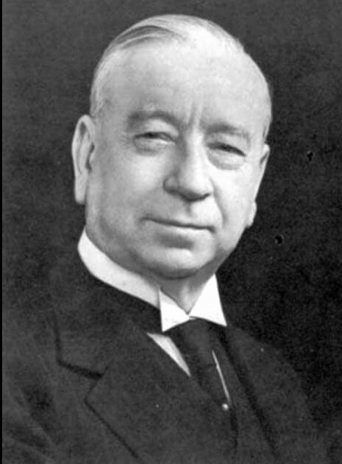
This engineer and inventor devoted himself from 1908 to 1951 (my year of birth) exclusively to the production of engine blocks that were used as built-in engines by about 75! motorcycle brands. There were famous brands, such as Brough-Superior; Chater Lea; Dollar; Matchless and Royal Enfield. The engines were also used in aircraft and light motor vehicles (cycle cars) (Morgan). Note the wing tip collar, also known as a ‘patricide’.
[John Alfred Prestwich (JAP), a rather quirky and confident-looking gentleman, but also a kind of friendly Dr. Dolittle, or some cynical W.C. Fields. In any case 'every inch a gentleman'.]
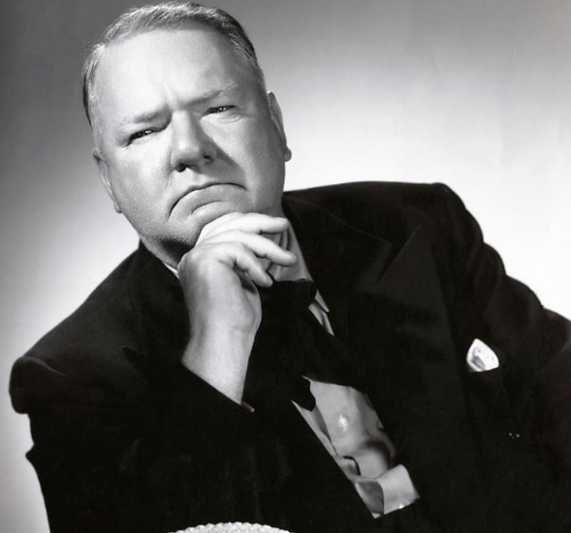
[Characteristic pose by W.C. Fields.] [Ad J.A.P. engine.]

Valuation
Martin Slancar calls this the most sophisticated desmo system. I totally disagreed of course and asked him what he means by 'sophisticated' and sent him the following overview:

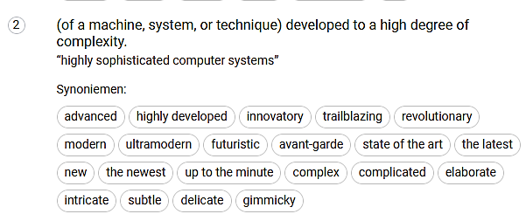
[Synonym overview of ‘Sophisticated’.]
Me: “I agree when you mean it is the most complex, complicated, and delicate, but most of the other synonyms certainly do not hold in my opinion in comparison with the many systems I know in depth.”
Me: “I just cannot comprehend that with an eccentric mechanism, coupled to a connecting rod, using a Kulissenhebel with a special calculated slot and precisely positioned anchor points, one can initiate a realistically timed valve movement. But I understand that your admiration (respect) re. ‘The unknown constructor’ was growing during your research of this desmo-system (engine).”
Unorthodox (his other qualification) it certainly is. High revs would not have been possible with this eccentric system and bicycle ball bearings. There are also many links in the chain that are susceptible to wear. As with the Packer Board Track Racer, reliability and longevity were not a priority, because winning a race was the goal. After that, such an engine block was repeatedly pulled apart and built up with new stuff.
Unfortunately, it is not clear whether it was ever further developed and phased out at the time; so, including the desmodromic valve control. Or that it has remained in the condition in which it was found and that J.A.P. left it at that time. History does not always reveal all its secrets.

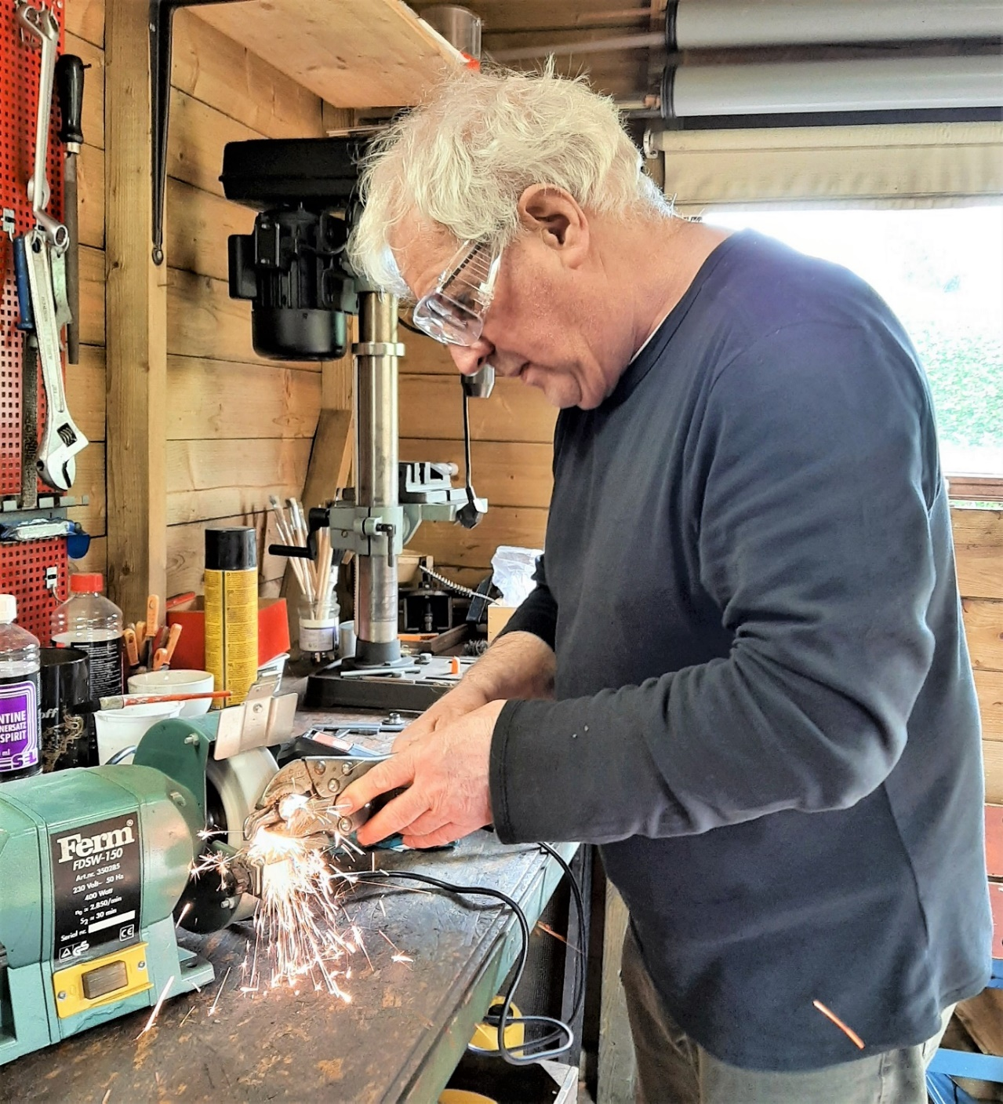
[Old Cloos in the garden shed-and adjoining workshop grinding the two Ducati opening rockers used in the model. Btw: not visible, but the EarPro motor-ear-gear protection is present.]
Static versus dynamic / Henk upset (pissed off).
After the model was statically assembled, I had to try to make the kinematic chain rotatable and functioning. It soon became painfully clear that it was - even with already disconnected 'cam' shafts - much too optimistic to let it work right away. Even when I disassembled just about everything and tried to get just a single rod through the dead centre, I was pressed to the hard facts. Even if I filed down the anchor link in the critical spot and dramatically reduced the contact area with the rod, it still didn't work. So that meant 'back to the drawing board', which means contacting Slancar and getting Vincent back to work (running simulations).
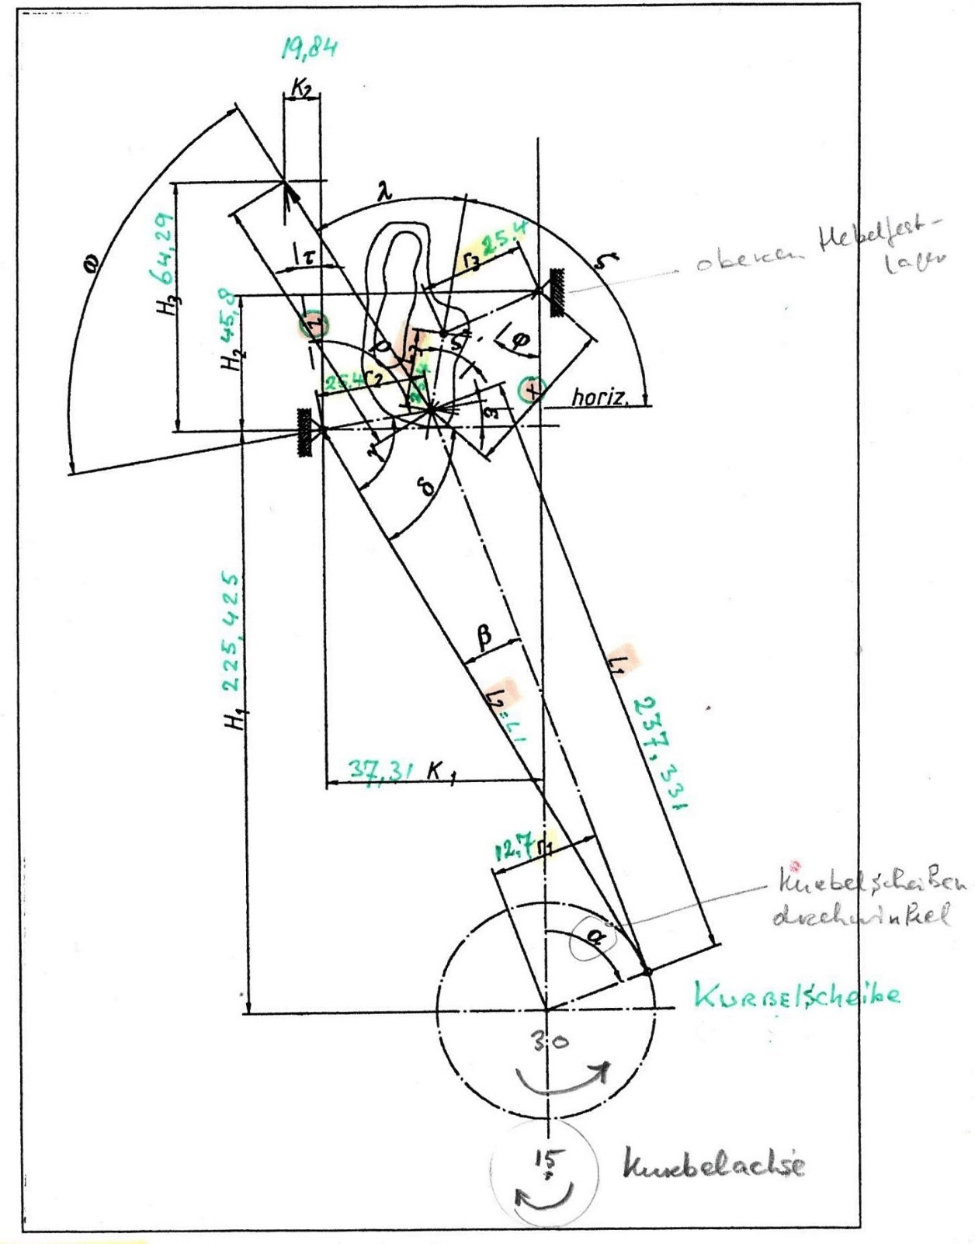
[Variables for the motion calculation. Shown is the intake valve control.]
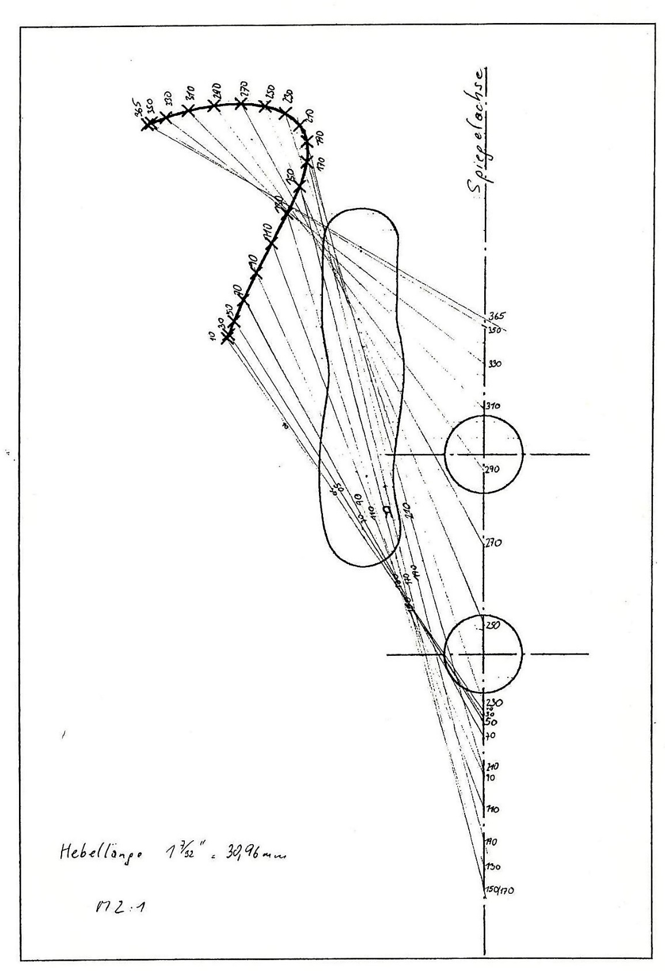
[The shape of the Kulisse partly determines the timing of the valve.]
The printed parts had a very rough surface and therefore required intensive post-treatment. The holes had to be reamed to size and the bearing raceways ‘machined’ by hand. Probably because the 'Ever Given' got stuck in the Suez Canal with the Dremel container from China, the ‘Praxis’ (Lumberyard) was completely sold out and sanding stuff was hard to get.
Never too old to learn
I downloaded two 3D software packages: FreeCad 0.19 and JT2Go. I practiced some with this software, but the possibilities are of course less extensive than the package that my cousin has available: the CAx package NX from Siemens.
Vincent also taught me the concept of 'entry control'.
In this case, that means checking the printed parts for the right quality, such as correct dimensions, tolerances, and roughness.
Because things got stuck, I investigated what could be the cause. The biggest mistake I made was failing to do the so-called entry check. So, I only found out (too) late that, for example, ± 1% shrinkage in those long rods can be quite a few millimetres. And so, it did (almost 4 mm). The links also turned out to be 0.75 mm shorter centre to centre. These deviations turned out to be too much of a good thing in this very critical system. But by then I had already messed around with machining parts (removing the material what was in the way) and even moving the eccentric hole 4 mm up.
Vincent ran the simulation software again and despite: “Nil volentibus arduum”: “For those who want, nothing is impossible”, the decision was made to put an end to it.
Yes, it is still possible to make a working model, but then I must have professional parts printed that exactly meet the dimensional tolerances. Have the coordinates drilled on the CNC milling machine and outsource various other jobs, such as grinding the bearing tracks in the eccentric and the rods. And 'Old Cloos' will not do that anymore! It's been nice and enough!
Conclusions:
It is a small miracle that after the sum of coincidences, I can report that my 'Unvollendetes' (unfinished) Model (Group X = No. 49/50 of my desmo catalogue) after all these years and attempts, unfortunately rather unsatisfactory, has come to some completion.
The model looks quite attractive; the operation is understandable, without being able to demonstrate it. With the preliminary work that has now been achieved, a third attempt could be promising, but it will not come to that. The parts to be printed will have to meet the dimensions exactly. Then you must go from hobby to professional service providers. The simulations have shown that if all dimensions and coordinates are correct, the model then offers barely any space for manoeuvre. The running surfaces of eccentric and rods must be treated in a professional manner. All this is going to cost a lot of money again and it's not worth it to me.
Fact sheet
Current owner is the German JAP collector a certain Mr. Dieter Mutschler.
The parts fit a 350 cc JAP mono racer.
The engine once ran, but it is not known whether, for example, a sound or video recording was made. Not even how long it ran. Only short-term cold or longer and surviving the thermal expansion.

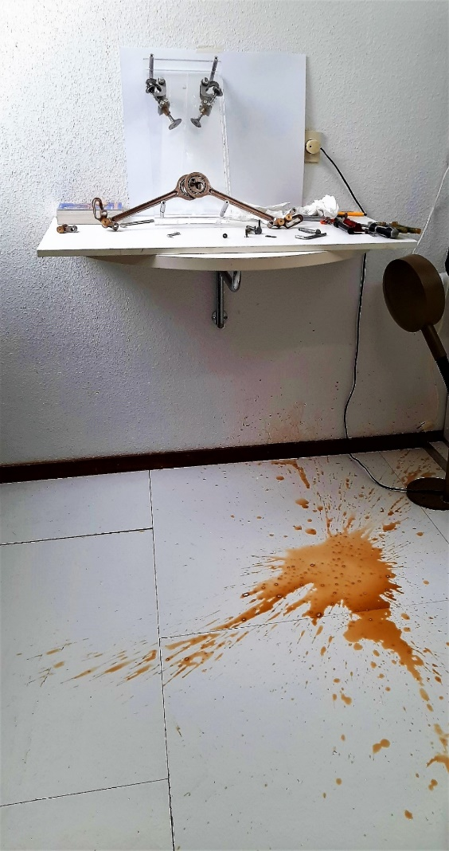
[Blood was spilled during the assembling (or was it coffee?).
[I could sometimes shoot myself in the head, but I fortunately don't have a gun.]

Documentation used
- Puzzle für Fortgeschrittene / Martin Slancar (tekst en foto’s) In: Motorrad Classic; 6/2002, p. 38-43.
- WWW. mal kurz reingeschaut In: Motorrad Classic; Nr. 1, 2003.
- Der Ventiltrieb eines JAP-Einbaumotors / Martin Slancar; 19-08-1999, p. 2-23.
- Un double ACT desmo en 1923! / François Dumas In: La vie de la Moto, n° 726 (29 novembre 2012).
Special thanks to: Martin Slancar and Vincent Cloosterman.
Text (in Dutch) and translation (in English) by Henk Cloosterman, July 2021.

