Packer Special Part 2
The story after Mat Oxley's article in Strada No. 6
Invited to become part of the Packer history, how is that? Paul Newsham Just "a bloke in a shed"?
At the end of June (2019), I received an e-mail from a certain Darren Wrudd, a close friend of Newsham. The article in Classic Bike had put them on the trail to the Packer page on "Desmodromology". He sent me some pictures of a mock-up (dummy) of the desmo system used in the Packer. I was pleased that I was not very wrong at the time when I came up with the possible system. It does indeed show a group IV system, albeit with only 1 instead of 2 countercams. [see: https://www.desmodromology.nl/classification-text/ ]
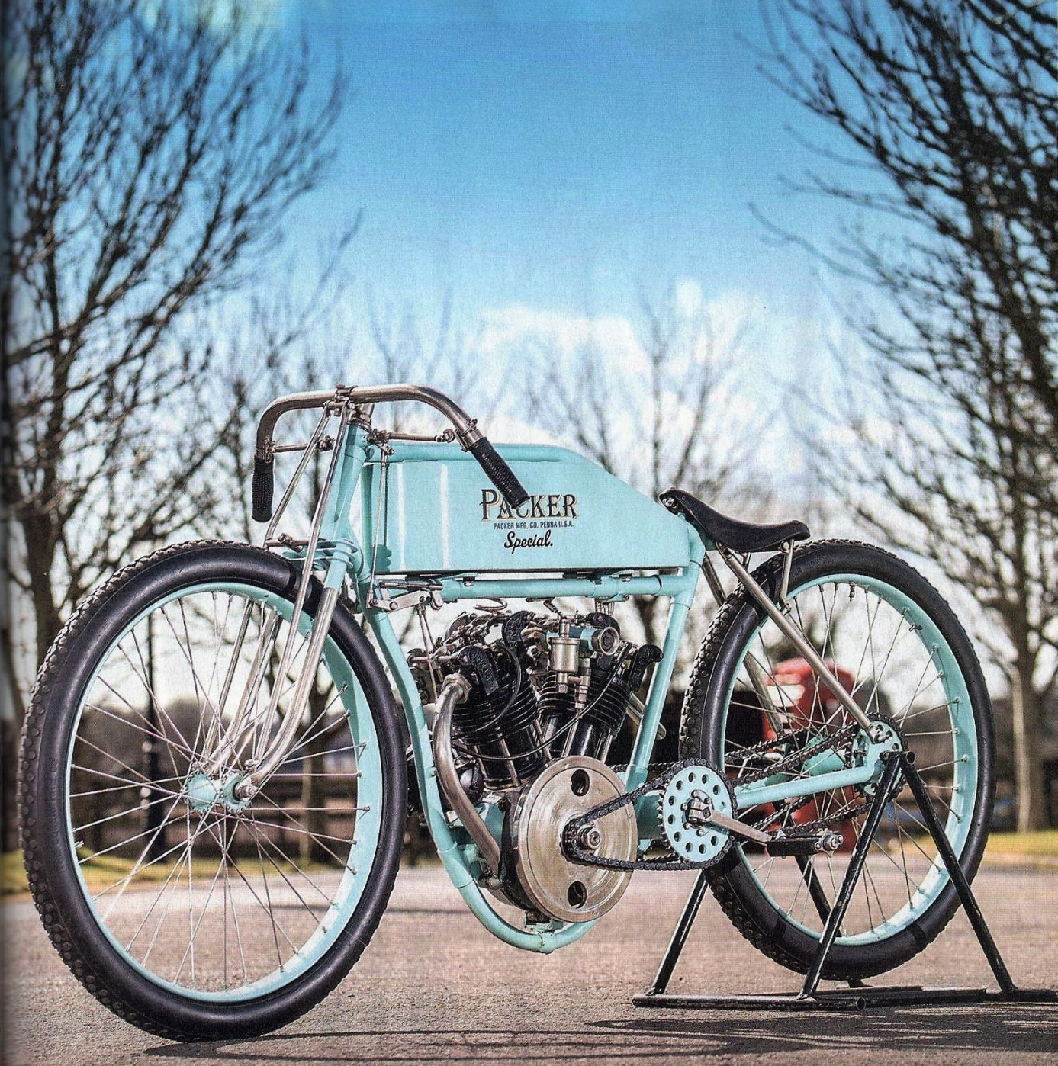
Even more than initially, Paul Newsham has remained a mystery to me. He was born in 1943 and lives in a simple, authentic working-class house from the industrial revolution (around 1800). Factory houses in streets back to back with a common, long corridor where in the morning (one did not have an individual mechanical alarm clock) someone went along the doors to call the workers to "The Mill" – (the factory). He has a simple workshop of only 3 x 2.5 meters in the former laundry house behind the lodge, where he manages to convert his many projects into metal. Newsham commented: "Engineering machine shops are usually in a similar state, as the boss pays workers to work, not tidy up. When you see a clean and tidy workshop, you can be sure little, or no work is being done." Newsham's creations are of an original quality. In the case of the Packer rather different from, for example, the bevel-gear engines of Fabio Taglioni.
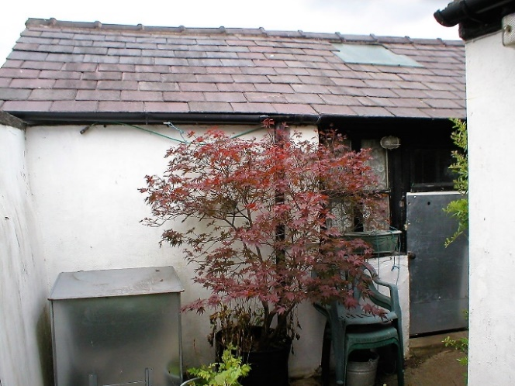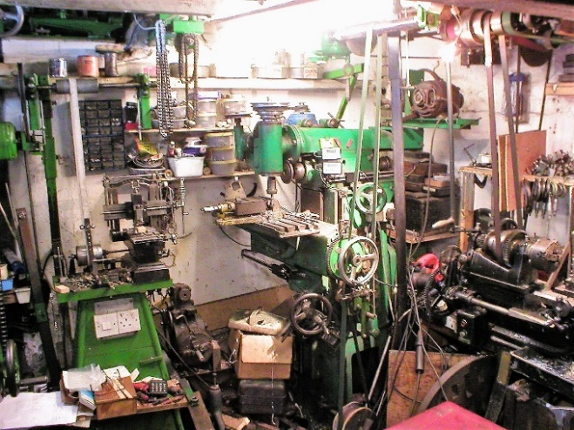
[Pauls’ shed)] [Interior of Pauls’ workshop]
When asked what his understanding was on and knowledge of desmodromics at the time of making the Packer desmo system and why the choice for this system, he replied: "... I couldn't understand the logic of opening a valve by a cam but closing it with a spring." Neither could I understand the logic of a horizontal camshaft with the need for a vertical drive.”
That is to say that in his view our Ducati bevel-gear engines were illogical and unnecessarily complicated. In this way, he devised a desmo in which he could omit the hard-to-produce bevel gears. One important starting point for him was being able to place the total long stroke engine in a standard - for that time common - "Loop frame". That brought him to a system that was not new and had already been implemented in 1914 but may well have been figured out by him. In summary in Newshams’ own words: "The simple answer to your question is: mounting the cams directly on the vertical shaft does away with the need to turn the drive through 90 deg(ree) at the head.”
Always exclusively with Darren’s' intervention, I first received one and later another twenty short written explanations from Newsham himself. Fairly unique for this publicity and attention-shy person. In it he explains the "Mystery" and explains how it all came about.
It started with the possession of a Hailwood Replica Ducati, whose desmo system he wanted to get to know. Yes, Paul is a Ducatist and even talks about "our lovely Ducati’s”. He was also interested in board track racers and in the period around the year 1914. Furthermore, as a mechanical maintenance engineer he had quite a bit of leisure time that he wanted to spend meaningfully. The name "Packer" simply comes from the wife of a good friend. She was once in Pennsylvania and saw a manhole cover with the inscription: "Philadelphia Penna 1914". He used that on the castings of the engine.
Also, the silence of Sammy Miller becomes a bit more understandable now. It was a preconceived idea to create some buzz with the Packer in and around the museum. Or as Newsham describes: "I thought it would be nice if the Packer was also put in his museum where it would create a talking point of interest, which it was done successfully." It was Sammy Miller himself who insisted that on the tank "Special." and "PACKER MFG." CO. PENNA U.S.A. " was added. Both expressions do not conform reality, because Packer (MFG = Manufacturing) never existed and there was nothing "Special." But it was quite effective to mislead the good municipality.
To be able to fit the engine block in the intended loop frame, it was therefore not possible to position the desmo system on top of the cylinder head. That is the second reason (apart from being able to omit the bevel gears), that Newsham has carried out the cam boxes next to the valves. The cam followers are made of steel and secured against tilting by bronze shoes that are attached to the cam housing with bolts.
Newsham prefers the taper fit connection and therefore does not use any keys in keyways. In this case, he had to turn on the lathe no less than three tapers on one single shaft. Two opposite each other for the cam pairs and at the bottom of the shaft for the coupling with the upper shaft piece. In addition to the press fitting, both cam pairs are also secured by bearings and nuts. By the way, the desmo system was already there before the rest of the engine. Newsham: "A complete cambox was made before any other part of the engine."
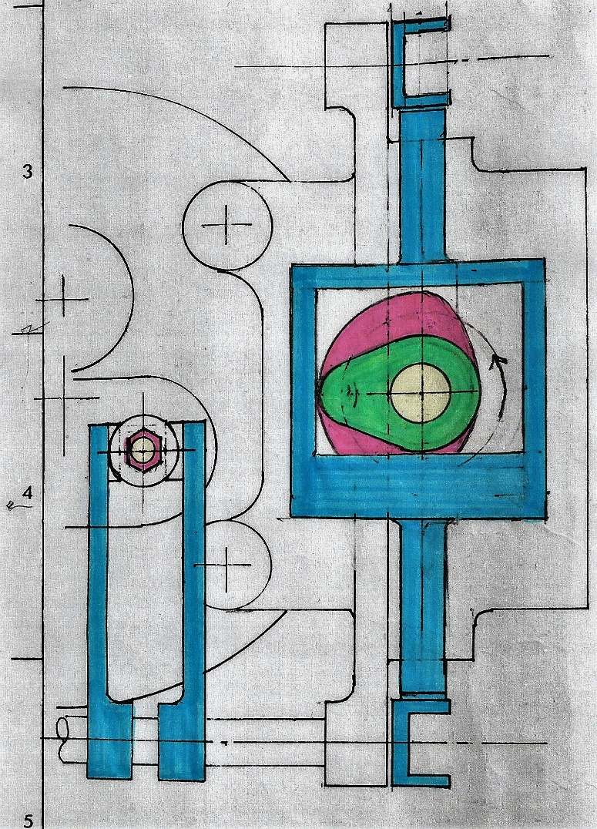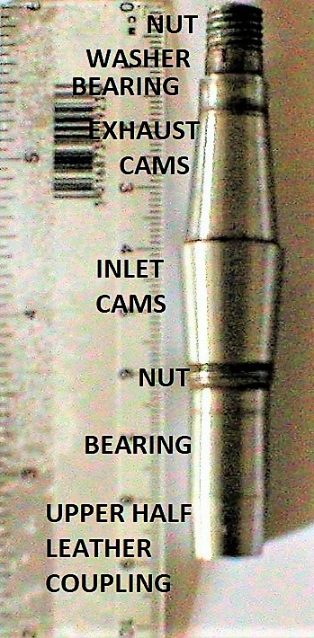
[Left: The self-coloured desmo system. The opening cam is green.] [Right: Small (9 cm), but a rather complicated shaft]
"The single con rod has a slave rod connected to it", as in radial engines, albeit that the Packer (other than shown in the picture) has an undivided big-end with roller bearing. Between the two shaft parts is a clutch/connection of leather or fabric discs (rag-joints, or disc-joints) to pass the rotating motion to the cam shaft and also to absorb some expansion and misallignment". In Ducati's and in a number of other bevel drive engines this happens with an Oldham coupling and with "self-aligning bearings".
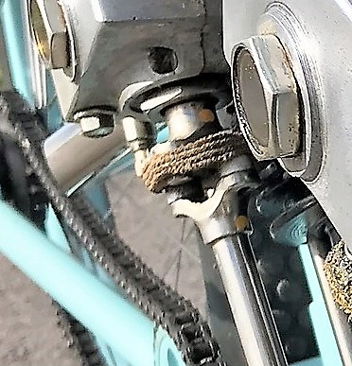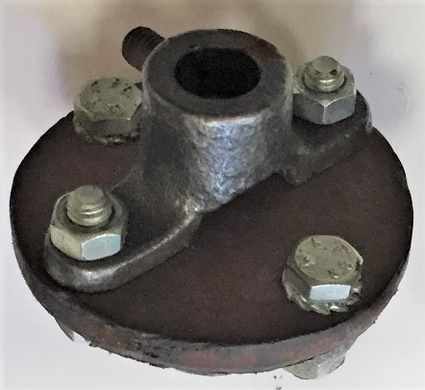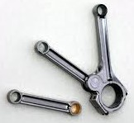

This coupling is simply a package of leather or cloth discs with 4 bolt holes. The Y-shaped "stirrups" are crossed with two holes each and there is no metal on metal contact. While the disk package drives the vertical shaft, she also takes care of the expansion. Not so much by pressing the package as such, but by the curvature that creates in it. The photo on the right is a dummy (of pipe braces and 1 piece of leather) as an example and is not used in the Packer.
My initial conclusion was that when using this kind of drive system, you can't ignore the desmo application. Because of that leather package (rag-joint) commanding a valve train with real heavy valve springs seemed almost impossible to me. But according to Darren, who has a business in bearings and Power Transmission Equipment, these couplings come in all shapes and sizes and transfer powers. Only by using those minor forces, Newsham could apply such a beautiful, charming, under dimensioned coupling.
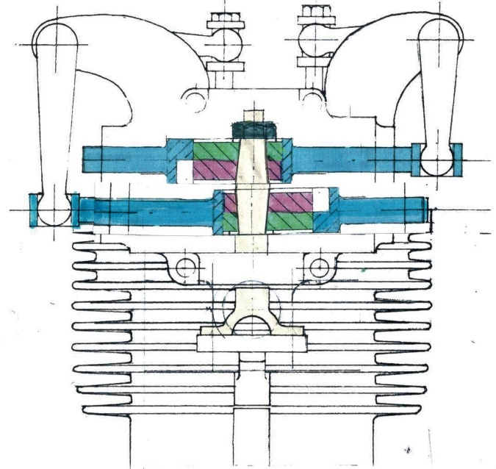
The special, old-fashioned font (with shadow) of the word Packer on the tank is the "EF Algerian", a 1911 design by Englishman Stephenson Blake.
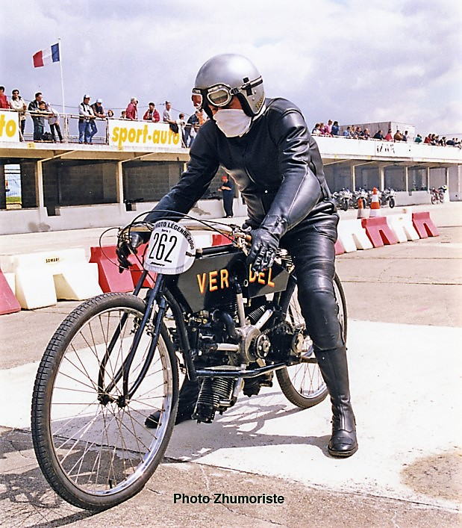
According to Newsham, the letter was 'designed' by his friend Patric Sproston (see photo), but he only searched and used the letter for this purpose. I discovered this font on the site: www.Identifont.com under the heading "Fonts by appearance”, answering questions like: “do the characters have serifs?” And 12 other questions.
[Patric Sproston on the VerDel copy made by Newsham.]

For a brass model plate I could choose from about 100 fonts at a store for sports prizes. I chose this somewhat old-fashioned and quite similar letter.
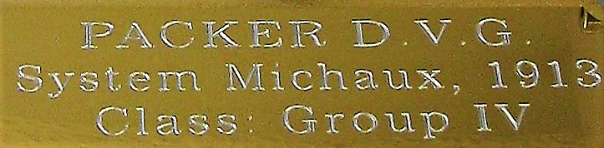
Packer was the only word on the tank when Newsham sold the motorcycle to Sammy Miller. It was this wayward man that added PACKER MFG. CO. PENNA U.S.A. and “Special.” (with a dot) to it.
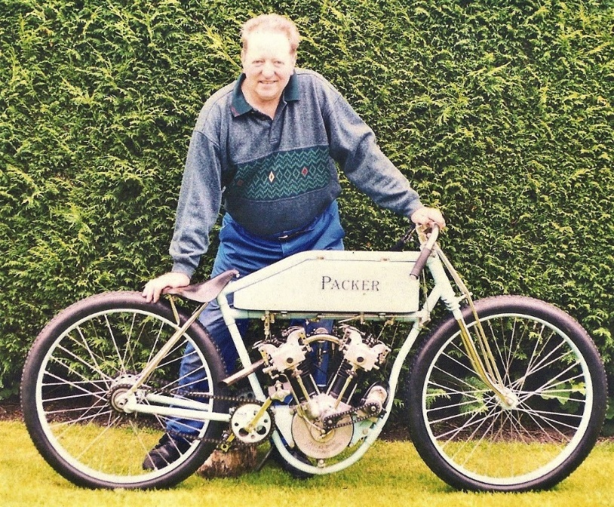
[Paul Newsham with his Packer (loop frame) before it went to Sammy Miller]
Newsham wanted to give this engine a touch of originality with the name on the tank and crankcase, without side intentions. However, Sammy Miller was different in the sense when he added more and officially presented the whole as being an original product from 1914. Something he also knowingly did with the Verdel. It is more common for old originals to be completely rebuilt and sometimes artificially undergo an aging process. At Yesterdays* If I had come across such a motorcycle, I could easily have been fooled by it.
Models:
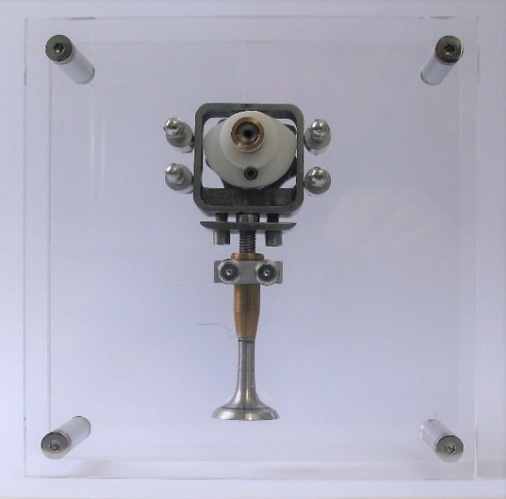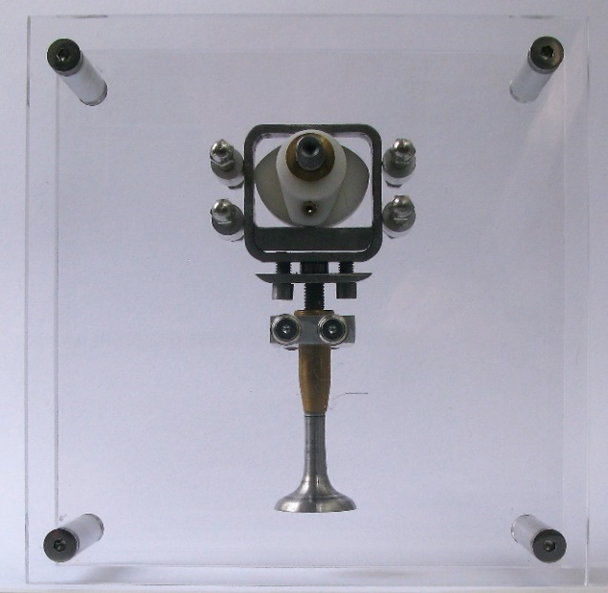
[System group IV with opened valve, shown from both sides]

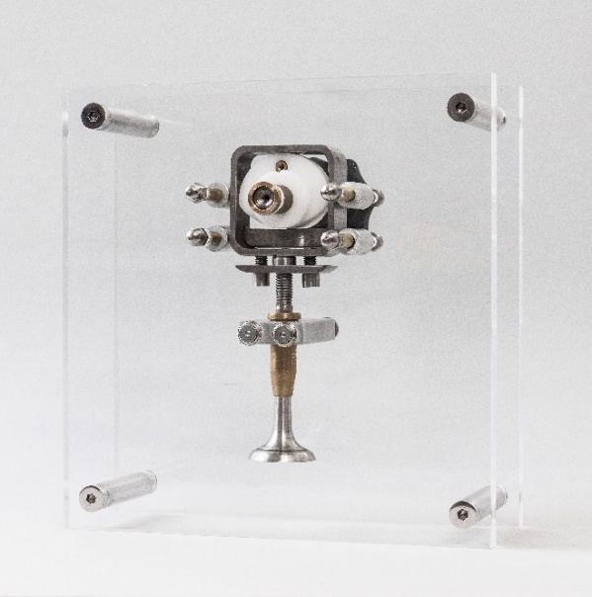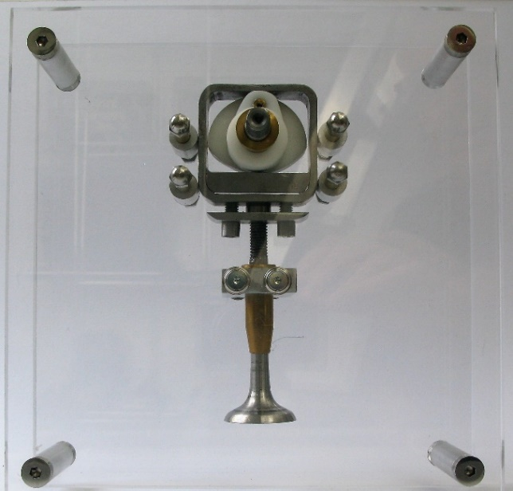
[System group IV with closed valve, shown from both sides]

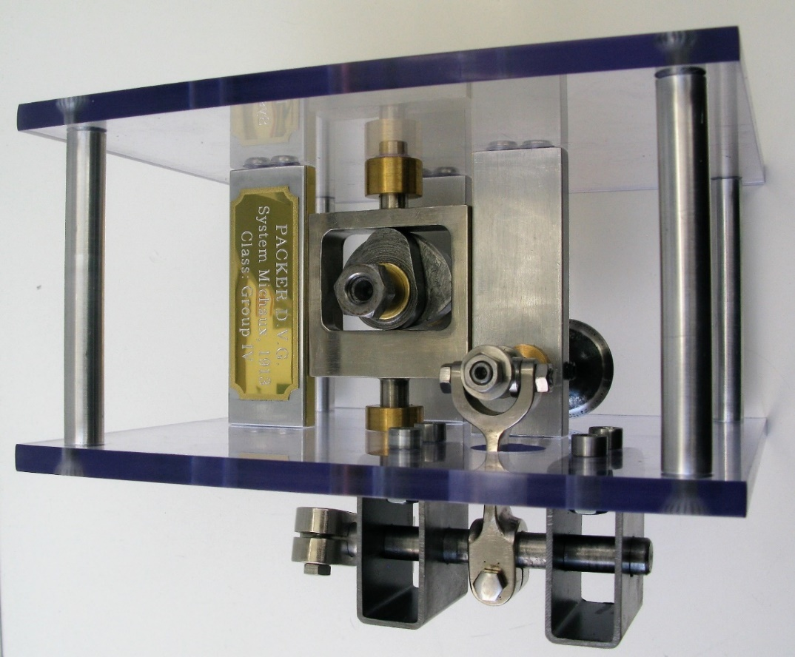
[Packermodel (valve closed = “slide” to the left). Note the lengths of the shafts between the two bronze bearings.]
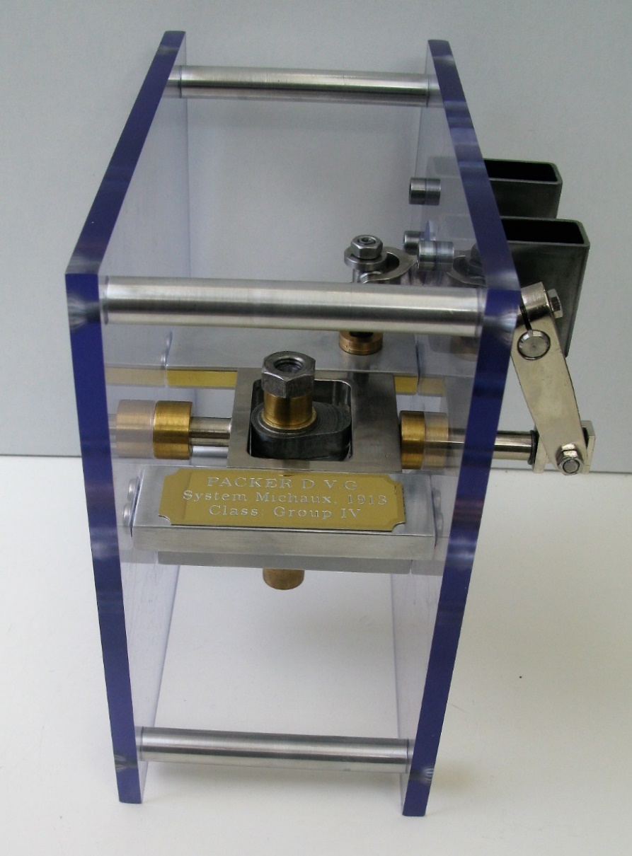
[Packermodel (valve open = “slide” to the right)] Newsham has supplied the cam shaft and the cam pair of the exhaust valve for this model. He wrote: "It would please me that in your ownership of the camshaft, you would become part of the Packer's history." Later Paul also sent me the slide, or the camfollower square with a thin shaft on both sides; the rocker connected to this shaft; a metal bar; the rocker connected to the valve; the valve / rocker connection (bobbin) and the small inlet valve with valve guide.
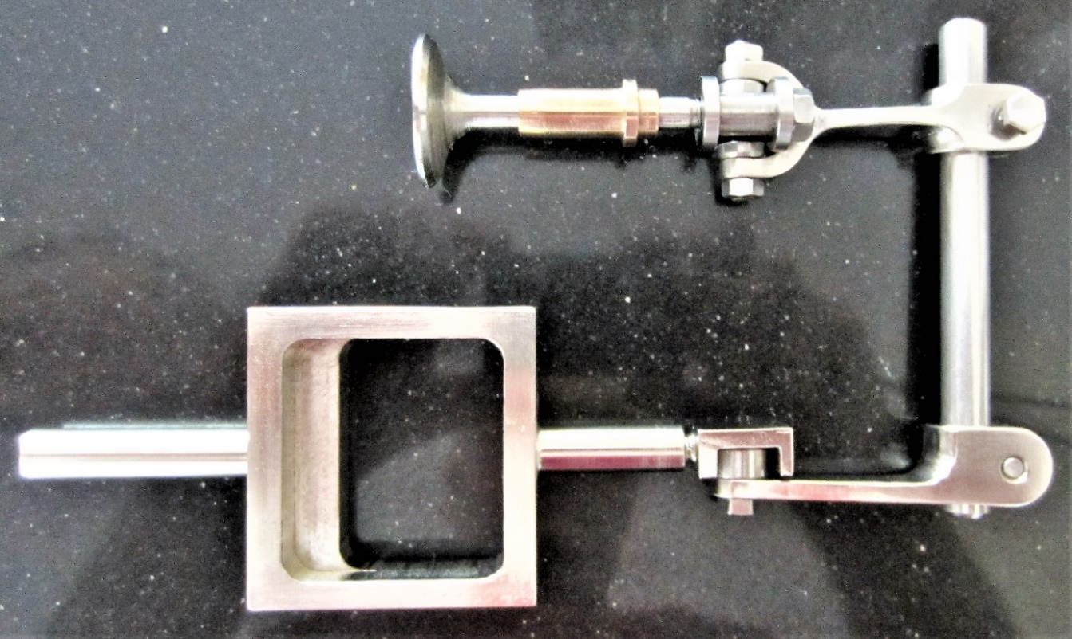
Despite all these already available parts, this became still a pièce de résistance, which took a lot of time. For instance: in the right Perspex plate I had to drill 15 holes without having a (CNC) milling machine, so to speak more or less 'off the cuff'. Furthermore, tempering two hardened valves to be able to turn them to a smaller diameter and cut thread on it. Note: In reality, the slide for commanding the exhaust valve is also on the same cam shaft as the inlet valve with such a slide. The latter then goes opposite with the long shaft and rocker on the other side.
The Packer B.T.R. as a motorcycle is a beauty, but the Packer desmo is not a very elegant and effective version. It looks a bit like old-fashioned steam locomotive technology, with which Newsham appears to be well acquainted. The total-loss lubrication of the desmo parts and the premise that the Packer would only have to go one race and then had to be rebuilt again, one could see it as an excuse for the lesser lifespan and quality of this type of system.
An oil filled cambox might have a speed limiter and therefore power inhibiting effect. This construction also does not allow sharp timing. I would rather go for other types of desmodromics and then especially the Ducati systems (with overhead camshaft).
Perhaps Newsham’s "Didn't think it was logical", might be a bit inspired by his limited technical possibilities. Making bevel gears in his own shop, for example, was quite a task.
The question remains whether in 1914 this desmodromic three-valve engine could offer paroli to other board track racers and even be a winner. A question that will always remain unanswered.
Paul Newsham regularly took the Packer into the countryside on a trailer to start her and hear her run idle, without disturbing the neighbors. He had provided an extensive document on the start procedure when she was sold to Sammy Miller. Mat Oxley recalled this in his article. With this information, these men managed to get the engine to run, which has produced a few spectacular photos with a lot of smoke and even a short video. To create a link to that Packer video from my website, I created a YouTube account ("Desmodromology").

Technical specs:
50 ° V-twin with Desmodromic OHV valve control
2 intake and 1 exhaust valve per cylinder head
Bore x Stroke: 79 x 100 mm.
No: Gear box, clutch, brakes, suspension, noise reduction through mufflers, primary and secondary chain shielding
Power, max. rpm, max. speed etc. : no specification
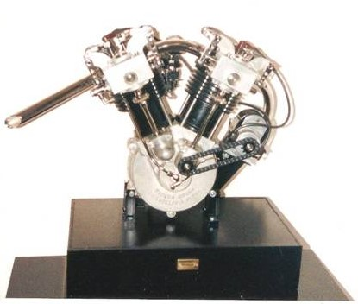
Note 1 It has been chosen not to translate certain statements etc. in English. There will be few STRADA readers who need it.
Note 2 The Packer is not a real bevel gear engine. This term comes from the mill construction and there is the transmission of the horizontal axis (on which the wicks are on) to the vertical axis (where the mill stones are attached to) regarding right angled transmission (cogs / "bevel-gears").
* Yesterdays: https://www.yesterdays.nl/ Antique Motorcycles Accessories and Related Articles
Translation: Henk Cloosterman, December 2019
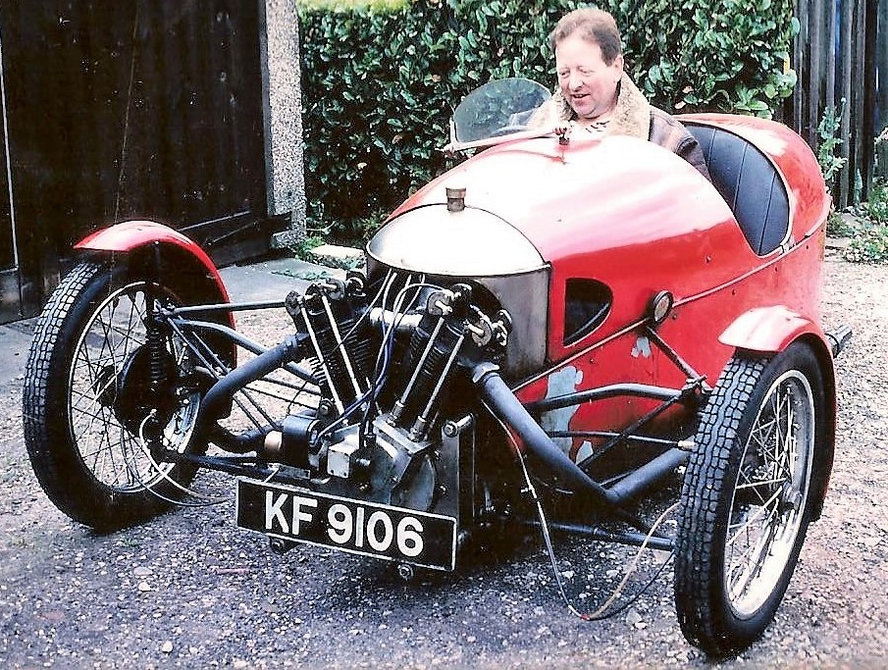

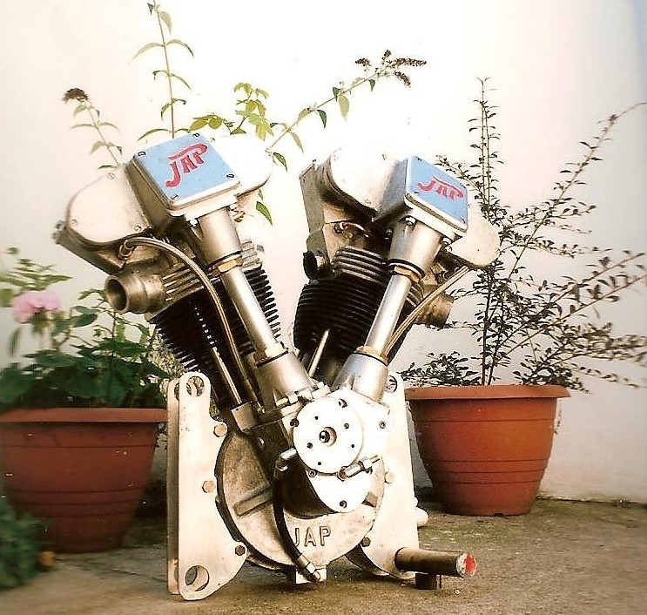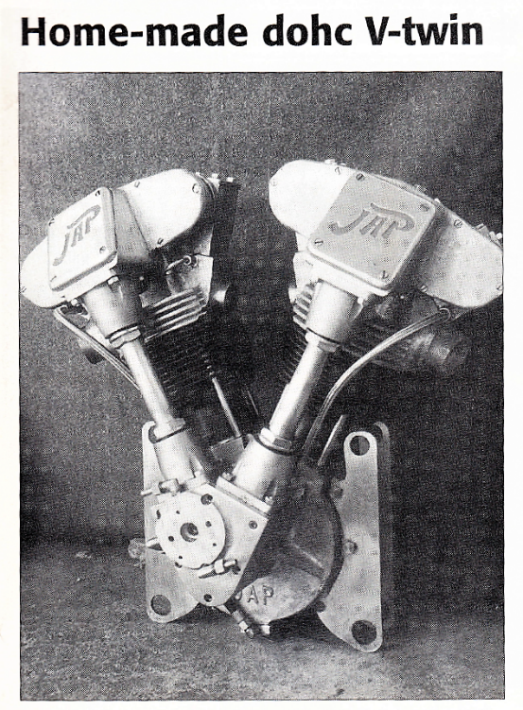
[Some more pics of Paul Newsham]

